Washington Technology Solutions

Enterprise Technology Solutions

Agency Financial Reporting System

COST ALLOCATION SYSTEM

September 2015

Table of Contents

Cost Allocation Functions
Cost Allocation System Overview 1
Financial Data Selected For Cost Allocation 3
Cost Allocation Data Elements 4
Cost Allocate Transactions 5
Cost Allocation Journal Voucher – CAS535 Report 6
Convert Base To Cost Objectives 8
Cost Allocation Tables and Relationships 9
Process Steps To Create The Cost Allocation Tables 10
CAS Table Roll & Build Plan Window 12
Automated Base Special Rules Fiscal Months 24, 01 and 02 13
By Pass Journal Voucher 13
Cost Allocation Data Element Input Screens
Cost Allocation Tables Maintenance Menu 14
Data Element Input Screens and Table Update Edits
Common To All Data Element Update Screens 15
Data Element Input Screens
Allocation Schedule 17
Allocation Base 18
Base Element 19
Base Element Sequence 20
Allocation Methodology 21
Cost Objective 22
Allocation Schedule Link 24
Base Element Sequence List 25
Appropriation Index Crosswalk 26
Multiple Base Elements Maintenance 27
Cost Allocation Reports
Cost Allocation Operational Reports 28
Chart To Assist In Selecting Operational Reports 29
Report Samples With Purpose and Data Element Descriptions Input Screen Tables – CAS60x Reports
Allocation Schedule Table Listing 30
Base Table Listing 31
Base Element Table Listing 32
Base Element Sequence Table Listing 33
Allocation Methodology Table Listing 34
Cost Objective Table Listing 35
Allocation Schedule Link Table Listing 36
Appropriation Index Crosswalk Listing 37
Plan Reports – CAS3xx Reports
Plan Build Error Report 38
Report Request Menu 39

Cost Allocation Reports continued
Plan Reports – CAS3xx Reports continued
Base Step Down and Final Allocation 40
Base Change Comparison 41
Enterprise Reporting Standard Reports 42
Associated Base Structure By Program 43
Base Structure Listing 44
Cost Allocation Plan 45
Cost Allocation Rate Variance Flexible 46
Target Base Listing 47
Target Cost Objective Listing 48
Target Schedule Listing 49
Cost Allocation Plan Table Maintenance 50
Table Roll Exception Reports – CAS61x Reports
Schedule Table Roll Exception Report 52
Base Table Roll Exception Report 53
Base Element Table Roll Exception Report 54
Sequence Table Roll Exception Report 55
Cost Objective Roll Exception Report 56
Schedule Link Roll Exception Report 57
Appropriation Index Crosswalk Exception Report 58

Appendix A – Batch Job Submission Screen 59

Appendix B – Cost Allocation Transaction Codes 62

Appendix C – Determine Allocation Plan 64

Appendix D – Glossary 65

Appendix E – Viewing AFRS Reports Online before Printing 66

Cost Allocation System Overview

The Cost Allocation System is a mainframe product offered, maintained and enhanced by Washington Technology Solutions (WaTech). The Cost Allocation System does not use an indirect rate. Cost allocation is based on distributing actual dollars and FTEs; Agency direct and overhead expenditures and FTEs are cost allocated as incurred.

Cost allocation is a process to build an Automated Cost Allocation Plan that mirrors the Written Cost Allocation Plan. The Cost Allocation System uses the Automated Cost Allocation Plan to cost allocate financial data.

Cost allocation distributes expenses and FTEs to cost objectives. A cost objective is a state program or federal grant. The cost objective has the federal and / or state share. The expense and FTEs either go directly to a cost objective or to a base (multiple cost objectives) with the proper Federal or State appropriation index.

The Automated Cost Allocation Plan is built as a monthly cost allocation plan from the cost allocation tables maintained in AFRS. Values in the cost allocation tables can be added, changed, deleted or inactivated each month. For a base methodology the amounts that provide the distribution between cost objectives can change each month. These additions and up-dates can occur until the new plan is created on the first day of the month. When the plan is created for the fiscal month only additions can occur to the AFRS cost allocation tables. These additions supplement or add to the cost allocation plan and allow transactions using these codes to cost allocate.

The AFRS financial data and FTEs is summarized AFRS transactions, selected and segregated by general ledger account and by fiscal month. The financial data is direct and indirect disbursements, accruals and encumbrances. The federal dollars disbursed, as identified in the cost allocation process, are billed to and reimbursed by the Federal Government. Cost allocated accruals and encumbrances are assigned the cost objective and appropriation index for financial reporting, and in limited cases for federal grant reporting.

The Cost Allocation System is integrated with AFRS. AFRS transactions in the nightly process identified for cost allocation are run against the cost allocation system edits. Transactions that do not pass the cost allocation system edits are sent to the AFRS error file. The good cost allocation AFRS transactions have a duplicate transaction created for cost allocation. The original transactions (non-duplicate) continue through the AFRS nightly processing and post to AFRS. The duplicate transactions have the unique codes stripped out and are merged, losing their unique identity. The merged transactions are cost allocated creating the AFRS cost allocation transactions. The merged transactions also create the reversing transactions for the original transactions. The AFRS transactions from the cost allocation system (cost allocation transactions and reversing transactions) are uniquely batch identified and inserted in the nightly processing and post to AFRS. The cost allocation transactions can be included in or excluded from the agency daily AFRS Transaction History reports within Enterprise Reporting.

Cost Allocation System Overview Diagram

Agency Chart of Accounts Structure State Assistance Program
Federal Grant
Biennial Written Cost Allocation Plan with Quarterly Updates
Fiscal Month Values for a Base
Create Cost Allocation AFRS Financial Transactions
Daily AFRS Financial Transactions
Select Financial Data
Cost Allocation Tables
Fiscal Month Automated Cost Allocation Plan
Process AFRS Transactions

Financial Data Selected For Cost Allocation

The general ledger account in financial transactions and the pertaining indicator is used to select the financial data for cost allocation. The general ledger accounts used to select the cost allocation financial data are as follows:

GL Acct Title
0120 FTEs Actual
0130 FTEs Accrued
0140 FTEs Liquidations
6510 Cash Expenditures (Dollars) 6505 Accrued Expenditures (Dollars) 6410 Encumbrances (Dollars)
51xx Liquidations (Dollars) – Pertaining indicator containing an “L” or “B”

Each of these general ledger accounts creates a record of financial data for cost allocation.

Examples of the transaction code general ledger account used to select financial data for cost allocation. Note the amount sign is determined by the position of the general ledger account. For the amount sign a debit is a plus and a credit is a minus.

Trans Code & General Ledger Accounts Examples | Pertain Indicator | General Ledger Account Selected | Amount Sign
894 0120 / 0998 | ?C | 0120 | plus
210 6505 / 5111 | ?C | 6505 | plus
833 5111V / 7140 | ?L | 5111 | plus
220 6510 / 7140 9510 / 6410 | ?C | 6510 &  6410 | plus minus
735 6410 / 9510 | ?C | 6410 | plus
001 1351 / 3205 | ?C

Cost Allocation Data Elements

AFRS financial transactions are selected for cost allocation based on the general ledger account and the pertaining indicator. A financial data record is created for each general ledger account. The unique data elements are removed and the financial data records are merged. Below is the level the financial data is cost allocated or these are the fields retained for cost allocation. Most of these data elements are user entered. A cost allocated transaction will contain these data elements selected from the AFRS financial transaction plus the data elements from the cost allocation process (system entered).
All cost allocated transactions include the following data elements: Agency
Biennium Fiscal Month
Pertaining Indicator . . . . . System entered data element value General Ledger . . . . . . . . Obtain from the transaction code Program Index
Allocation Code Fund (Account)
Appropriation Index . . . . Obtain from the original transaction Object
Sub-Object
Sub-Sub-Object Organization Index
Budget Unit. . . . . . . . . . . From D65 table program index / organization index Project Structure . . . . . . Optional data element
Month of Service . . . . . . Optional data element
Amount . . . . . . . . . . . . . Signed based on the general ledger account debit (+) /
credit (-) and the reverse indicator (R)

The cost allocation process creates multiple cost allocated transactions and inserts these data elements in addition to the data elements above.
All these data element values are system entered:

Fund (Account) . . . . . . . . Obtain from the appropriation index Appropriation Index . . . . Obtain from the appropriation index crosswalk Cost Objective
Cost Allocation Funding Type
Amount . . . . . . . . . . . . . . When the transaction code is inserted the amount is
unsigned.
Transaction Code (Appendix B) The general ledger account is removed Reverse, if applicable (Appendix B)
Batch Type Batch Number
Current Document Number Current Document Date Process Date / Time

210 = 6505 / 5111
398 = 5111 / 7120 6510 / 6505

Example of Creating Cost Allocate Transactions

TC | Vndr | Fund | Appn Idx | Prgm Idx | Alloc Code | SObj SSObj |  | Org Idx | C Obj | CAFT | Amount
398 ABC 760 SJ1 E3112 9999 GC 0400 E71B 400.00

See "Convert Base To Cost Objectives" page for the computation of this table

Yes

AFRS
Error File
AFRS Nightly Processing Edits
Pass Edits
No
Prgm Idx | Alloc Code | C Obj | Federal | State | Local
E3112 | 9999 | A005C | 0.0% | 32.0% | 0.0%
 |  | 777B2 | 27.2% | 0.0% | 0.0%
 |  | 777F2 | 30.6% | 10.2% | 0.0%

Original Transaction

Trans for GL 6510
TC | Vndr | Fund | Appn Idx | Prgm Idx | Alloc Code |  | SObj SSObj |  | Org Idx | C Obj | CAFT | Amount
669 760 SJ1 E3112 9999 GC 0400 E71B A005C S 128.00
669 001 VA1 E3112 9999 GC 0400 E71B 777B2 F 108.80
669 001 VA1 E3112 9999 GC 0400 E71B 777F2 F 122.40
669 760 SJ1 E3112 9999 GC 0400 E71B 777F2 S 40.80
670 760 SJ1 E3112 9999 GC 0400 E71B N 400.00
 |  |  |  |  |  |  |  | Cost Allocation Transactions

Similar trans for GL 6505 669 = 736 R, 670 = 736
CAS535 Rpt
Cost Allocation Journal Voucher

Two Transactions Trans for GL 6510 Trans for GL 6505

AFRS Nightly Processing

Report Number: CAS535
Title: Cost Allocation Journal Voucher

300-0 | DEPT OF SOCIAL AND HEALTH SERVICES | AGY PAGE: | 1
RPT CAS535 | COST ALLOCATION JOURNAL VOUCHER | 15/09/12 (12:59)
BIEN: 17
FM: 04 | JV DOCUMENT NUMBER: JVFS0012
TRAN TYPE TC REV FUND APP PI ALLC SOBJ SSOBJ ORG BU MOS PROJ SPRJ PHAS COBJ TYPE AMOUNT GL SUB-DR SUB-CR
--------- --- --- ---- --- ----- ---- ----- ----- ----- --- ---- ---- ---- ---- ----- ---- ---------------- ---- ------ ------ 6510 264 001 EE1 E1499 9999 AA 9999 E900 X01 N 481.62
6510 263 001 EE1 E1499 9999 AA 9999 E900 X01 U2AA2 S 480.42
6510 263 001 VM1 E1499 9999 AA 9999 E900 X01 U2AA2 F 1.20
6510 669 001 VA1 E5521 3361 JK 5000 E460 X49 0204 GAUP RJ 10 777F2 F 2.71
6510 670 001 VA1 E5521 3361 JK 5000 E460 X49 0204 GAUP RJ 10 777G2 F 399.78
6510 669 03C QB1 E5521 3361 JK 5000 E460 X49 0204 GAUP RJ 10 N 928.61
6510 670 03C QB1 E5521 3361 JK 5000 E460 X49 0204 GAUP RJ 10 A005C S 132.66
6510 669 03C QB1 E5521 3361 JK 5000 E460 X49 0204 GAUP RJ 10 777F2 S .90
6510 670 03C QB1 E5521 3361 JK 5000 E460 X49 0204 GAUP RJ 10 777G2 S 399.78

51XX 833 R 001 011 E5521 3361 ER 9560 E900 X49 N 1,000.00 5111
51XX 833 001 011 E5521 3361 ER 9560 E900 X49 A005C S 142.86 5111
51XX 833 R 001 011 E5521 3361 ER 9560 E900 X49 A005C S .01 5111
51XX 833 R 001 011 E5521 3361 ER 9560 E900 X49 777F2 S .97 5111
51XX 833 001 011 E5521 3361 ER 9560 E900 X49 777G2 S 430.52 5111
51XX 106 001 021 E5521 3361 ER 9560 E900 X49 777F2 F 7.70 5111
51XX 833 R 001 021 E5521 3361 ER 9560 E900 X49 777F2 F 2.92 5111
51XX 103 001 021 E5521 3361 ER 9560 E900 X49 777G2 F 1,136.11 5111
51XX 833 001 021 E5521 3361 ER 9560 E900 X49 777G2 F 430.52 5111
51XX 106 181 071 E5521 3361 ER 9560 E900 X49 N 2,638.94 5111
51XX 103 181 071 E5521 3361 ER 9560 E900 X49 A005C S 376.99 5111
51XX 106 181 071 E5521 3361 ER 9560 E900 X49 777F2 S 2.57 5111
51XX 103 181 071 E5521 3361 ER 9560 E900 X49 777G2 S 1,136.11 5111
6505 736 R 001 VA1 E5521 3361 JK 5000 E460 X49 0204 GAUP RJ 10 777F2 F 2.71
6505 736 001 VA1 E5521 3361 JK 5000 E460 X49 0204 GAUP RJ 10 777G2 F 399.78
6505 736 R 03C QB1 E5521 3361 JK 5000 E460 X49 0204 GAUP RJ 10 N 928.61
6505 736 03C QB1 E5521 3361 JK 5000 E460 X49 0204 GAUP RJ 10 A005C S 132.66
6505 736 R 03C QB1 E5521 3361 JK 5000 E460 X49 0204 GAUP RJ 10 777F2 S .90
6505 736 03C QB1 E5521 3361 JK 5000 E460 X49 0204 GAUP RJ 10 777G2 S 399.78
Purpose: Provides a listing of the cost allocated transactions grouped by Biennium, Fiscal Month and JV Document Number

Period: Daily each time cost allocation runs

Sort: Line Break: (Insert a blank line when different) (For each Biennium and Fiscal Month combination
a unique JV Document Number is assigned)

Biennium Fiscal Month
Transaction Type General Ledger Account Transaction Type

Disbursement Dollars | 6510
Liquidation Dollars | 51xx
Accrual Dollars | 6505
Encumbrance Dollars | 6410
Disbursement FTE | 0120
Liquidation FTE | 0140
Accrual FTE | 0130
FM99/25 & CM Inter-Fund | 1353
FM99/25 & CM Inter-Fund | 5153
Pertaining Indicator
Program Index |  | Program Index
Allocation Code |  | Allocation Code
Fund (Account)
Appropriation Index
Object |  | Object
Sub-Object |  | Sub-Object
Sub-Sub-Object |  | Sub-Sub-Object
Organization Index |  | Organization Index
Project |  | Project
Sub-Project |  | Sub-Project
Project Phase |  | Project Phase
Month Of Service |  | Month Of Service
Cost Objective
Cost Allocation Funding Type
Subsidiary Debit
Subsidiary Credit

Convert A Base To Cost Objectives - Occurs In Plan Build
Percent is distributed by percents

the next level percent)
Base 618

Elem 618-010 20.0% C Obj 777B2 20.0%

The CAS351 Report - "Base Step Down and Final Allocation" is a similar presentation

Elem 618-020 80.0%
Base 473 80.0%

Elem 473-020 60.0%
Base 558 48.0%

Elem 473-040 40.0% C Obj A005C 32.0%

Elem 558-070 15.0% C Obj 777B2 7.2%
Elem 558-080 85.0% C Obj 777F2 40.8%

Recap of above. Note total of C Obj percents is 100.0%
 | Elem 618-010 | C Obj 777B2 20.0%
 | Elem 473-040 | C Obj A005C 32.0%
 | Elem 558-070 | C Obj 777B2 7.2%
 | Elem 558-080 | C Obj 777F2 40.8%

20.0% + 7.2%
The Federal, State, Local share (%) are in the Cost Objective
Prgm Idx | Alloc Code | C Obj | Federal | State | Local | Total
E3112 | 9999 | A005C | 0.0% | 32.0% | 0.0% | 32.0%
 |  | 777B2 | 27.2% | 0.0% | 0.0% | 27.2%
 |  | 777F2 | 30.6% | 10.2% | 0.0% | 40.8%

CA Input Screens Codes Entered
Cost Allocation Tables and Relationships

Cost
 Cost Objective
 Fed, St, Loc %
 Fed % Rev Src
 Inactive FM
Seven cost allocation tables are shown. These tables minus the Methodology table are used in the build plan. One other table, the appropriation index crosswalk, is used when tranactions are cost allocated.
Objective

- Methodology

Base
 Elements
 Target
 Value
 System calc %

Cost Objective

Program Index

Allocation Code
Manual Value is user entered
Automated Value is from sequence(s) and is real time value
System provides real time percent
Converts to cost
objectives
Target
or
Look-up prior closed fiscal month value
based on program index / allocation code combination plus user entered adjust value
Automated Base
plus
 Allocation Method
 Allow for Auto

- Base
 Base
 Auto or Manual
 Rolling or Fixed
 Value From, To

- Element

- Sequence

Deleting a base deletes associated elements and sequences.

Schedule

 Schedule
 Target
 Admin, Client,
or Both

Target or

Base
Sequence(s)

Cost Objective

Schedule Link

Program Index

plus

Allocation Code

Target

Schedule
Deleting a schedule deletes associated schedule links

At the beginning of each biennium certain tables will be rolled into the new biennium and they are:
- Phase 1 General Table Roll
  - TM.1.1 = Descriptor Maintenance
    - Table 13 = Budget Unit
    - Table 32 = General Ledger Account Subsidiary Account
    - Table 36 = Revenue Sub-Source
    - Table 63 = Allocation Code
    - Table 65 = PI-OI (TM.6.2)
    - Table 93 = Month of Service Edit (TM.6.3)
  - TM.2.3 = Organization Index Maintenance
- Phase 2 Program Table Roll
  - TM.1.1 = Descriptor Maintenance
    - Table 16 = Program
    - Table 17 = Sub-Program
    - Table 18 = Activity
    - Table 19 = Sub-Activity
    - Table 20 = Task
  - TM.2.2 = Program Index Maintenance
- Phase 3 Appropriation Table Roll (After Budget passes.)
  - TM.1.1 = Descriptor Maintenance
    - Table 07 = Appropriation
  - TM.2.1 = Appropriation Index Maintenance
- Unique Roll for CAS Tables (Mid June of odd year)
  - TM.6.4 = Year-End Program Index (D71)
  - TM.6.5 = Year-End Program Index (D74)

The steps to create a new cost allocation table are listed below. These tables are used to edit the AFRS transactions and to build the monthly cost allocation plan.

  - Access the TM.1.1 screen titled Descriptor Maintenance and enter these codes:
    - Table 07 = Appropriation
    - Table 13 = Budget Unit (if applicable)
    - Table 16 = Program
    - Table 17 = Sub-Program (if applicable)
    - Table 18 = Activity (if applicable)
    - Table 19 = Sub-Activity (if applicable)
    - Table 20 = Task (if applicable)
    - Table 32 = General Ledger Account Subsidiary Account
    - Table 36 = Revenue Sub-Source
    - Table 63 = Allocation Code

  - Access the TM.2.1 screen titled Appropriation Index Maintenance and enter the appropriation indexes.
  - Access the TM.2.2 screen titled Program Index Maintenance and enter the program indexes.
  - Access the TM.6.1 screen titled CAS Edit-1 Maintenance (D72) and enter the function, program, sub-program and appropriation index relationship.
  - Access the TM.6.2 screen titled Table Maintenance (D65) (Edit-2) and enter the program index and organization index relationship and enter the budget unit. Budget unit is on the AFRS transaction input screen. The nightly AFRS transaction processing makes a look-up to this table and will insert the budget unit code in the transaction (also if found in the table it replaces a user entered budget unit).
  - Access the TM.6.F screen titled Cost Objective Maintenance and enter the cost objectives.
  - Access the TM.6.E screen titled Allocation Methodology Maintenance and enter the approved methodologies.
  - Access the TM.6.B screen titled Allocation Base Maintenance and enter the bases.
  - Access the TM.6.C screen titled Base Element Maintenance and enter the base elements.
  - Access the TM.6.D screen titled Base Element Sequence Maintenance (if applicable, used only for automated bases) and enter the sequence records.
  - Access the TM.6.A screen titled Allocation Schedule Maintenance and enter the allocation schedules.
  - Access the TM.6.G screen titled Allocation Schedule Link Maintenance and enter the schedule links.
  - Access the TM.6.I screen titled Appropriation Index Crosswalk Maintenance and enter the appropriation indexes and program (if applicable; the look-up is first by AI
- Program, then AI - no Program).
  - Access the TM.6.J screen titled Multiple Base Element Maintenance to review the allocation values entered on screen TM.6.C or to enter the values. This screen is a stream-lined way of accessing the base elements for view or data entry. Users can only view or up-date a future fiscal month.
  - Access the TM.6.H screen titled Base Element Sequence List to view a listing of the sequence records in a base element.
  - Access the TM.6.R screen titled CAS Report Selection to view two mainframe reports and run the preliminary plan build. The preliminary plan build can only be run for a future fiscal month, after the prior fiscal month is closed (i.e. January FM19 the prior FM closes, February FM20 the current FM is open, and March FM21 the future FM is available for a preliminary plan build report.) A preliminary plan build report can be run as often as needed. Each time a report is run from this screen DIS bills your agency.

Table Roll and Build Window

The CAS table roll and table build window is related to the AFRS fiscal months. The sequence is as follows:

Current Fiscal Month and Future Fiscal Month
At prior fiscal month close, the table codes in the current fiscal month roll to a future fiscal month. If roll = “N” for a base do not roll the base, the base elements and the base sequences; if roll = “N” for a schedule link do not roll the schedule link. The automated bases use the values from the prior fiscal month. To perform updates on the future month, the prior month must be closed.

When the tables roll creating the future fiscal month, the use code on each record is set to “N”. The future fiscal month table update is based on the table edits and the record use code set to “N”. Table records used in the preliminary build plan retain the use code of “N”.

After the prior fiscal month close and the table roll to create the future month, the current fiscal month table update (the use code on the current month records is equal to “N”) automatically rolls the action to the future fiscal month. During the nightly processing, the current fiscal month table adds, changes or deletes will update the current plan.

Prior Fiscal Month and Current Fiscal Month
The build plan occurs when the future month becomes the current fiscal month (the first working day of the calendar month). When the table records are used in the plan the record use code is changed to equal “Y”. After the build plan on the first working day of the calendar month, there are two fiscal months open, the prior and the current. With two open fiscal months, no roll occurs from an up-date in the prior fiscal month to the current fiscal month; table maintenance is independent on each open fiscal month table.

Special rules for FM24, 01 and 02
There are special rules for FM24, 01 and 02 for the automated bases. When FM22 closes, FM23 rolls to FM24 and 01. An add, change or delete in the current FM23 or future FM24 or current FM24 rolls to FM01.

Base Special Rules Fiscal Months 24, 01, and 02

These rules are for add, change or delete to a base and associated elements or sequences. Rules for when the table rolls are not included.

Manual Base
A manual base follows the other fiscal month rules for fiscal months 24, 01 and 02 A new manual base and associated elements can be added.
For an existing manual base, if the base is not used in the plan:
- The base with associated elements can be deleted.
- Associated elements can be added, changed and deleted.
For an existing manual base used in the plan, associated elements cannot be added, changed or deleted.

Automated Base
FM24 is the future month, can add, change or delete an automated base and associated elements and sequences.

If an automated base exists in FM24, it must be identical if it exists in FM01or 02. Therefore,
FM24 is the current FM or prior FM can add an automated base if not in FM01.
FM24 is the current FM or prior FM can delete an automated base if the base is not used in the plan.
FM24 is the current FM can add, change, or delete an element or sequence if the base is not used in the plan.
FM24 is the prior FM can add, change, or delete an element or sequence if the element or the sequence does not exist in FM01and if the base is not used in the plan.

FM01 or 02 can add a base if the base does not exist in FM24.
FM01 or 02 can delete a base if the base is not being used in the plan.
FM01 or 02 can add, change, or delete an element or sequence if the element or sequence does not exist in FM24 and the base is not being used in the plan.
One exception to this statement is the target cost objective can be changed on the Base Element for FM01or 02 if it is a future FM.

A new automated base (with new elements and sequences) can be added to FM01 and
- For a new base added, the sequences will only use the sequence adjustment value:
  - The sequence data value must be zero.
  - The sequence adjustment value is required (zero or greater).

An automated base rolled to FM01 or 02:
  - Keep the base from and to and the total value as is.
  - Keep the element total value and percentage as is.
  - Keep the sequence value and adjustment as is.

By Pass Journal Voucher

At times it is necessary to enter cost allocated AFRS transactions for nightly AFRS processing. These transactions are already cost allocated and these transactions should not be selected for the cost allocation process. To keep these AFRS transactions from selection for cost allocation, the word ‘ByPass’ is entered in the reference document field.

Cost Allocation Tables Maintenance Menu

=== AFRS =(TM.6)======== CAS TABLES MAINTENANCE MENU ============= C105P170 ===
TR: ______

1 -- EDIT-1 (D72)
2 -- EDIT-2 (D65)
3 -- MOS CONTROLS (D93)
4 -- YEAR-END PROG INDEX (D71)
5 -- YEAR-END ORG INDEX (D74)

A -- ALLOC SCHEDULE F -- COST OBJECTIVE
B -- ALLOC BASE G -- ALLOC SCHEDULE LINK
C -- BASE ELEMENT H -- SEQUENCE LIST
D -- BASE SEQUENCE I -- AI CROSSWALK
E -- ALLOC METHODOLOGY J -- BASE ELEMENTS UPDATE
R -- REPORTS

SELECT FUNCTION: _

F1=EDIT-1, F2=EDIT-2, F4=MOS, F5=D71, F7=D74

F3=RETURN, F12=MESSAGE, CLEAR=EXIT

Access: To display the above menu you will need to login to AFRS
On the AFRS primary menu type in “TM” into the Select Function field and press [enter]. This will bring you to the Table Maintenance Menu where you will type in “6” into the Select Function field and press [enter].

Purpose: The numbers 1 through 5 at the top provides navigation to descriptor table screens. These custom screens are the only means of up-dating these descriptor tables. Tables 1 through 3 are relational edits. Tables 4 and 5 are for new biennium index replacement. Numbers 1 through 5 are for transaction processing and they are not part of the CAS.
The letters A through R in the middle of the screen provides navigation to the cost allocation system screens. The update to the cost allocation data element tables and the required information for each data element occurs on these screens. The screens have a print capability to print the current table data elements and required data element information. Cost allocation reports, identifying relationships between the table data elements are available from Enterprise Reporting.

Navigation: At the Select Function field type in a number or letter and press [enter] to navigate to an input screen. Also navigate to any other screen by typing in the screen identification after “TR:” in the upper left corner of the screen, i.e. on this screen typing “TM.6.A” and pressing enter navigates to screen “A – Allocation Schedule Maintenance”. Navigate to another screen by [pressing] the PF key identified at the bottom of each screen.

Common To All Data Element Update Screens

Screen Information:
    - Created: Date record was created.
    - Last Update: Date record was last updated. Blank until an update occurs.
    - By: The last record update Requested By person.

Function: At the Function field user types in a letter and other data element values based on the Function and will press [enter]. The screen solid lines are data elements that are required, unless identified as an ‘or’ with another data element. The screen dotted lines are protected data element values displayed from the same or other tables.
    - Update is A=Add, C=Change, D=Delete
    - Display is V=View, N=Next, B=Back
    - Print is P=Print. For tables by fiscal month, only one fiscal month prints. If the fiscal month is not entered, then the table print will default to the current fiscal month. Press [enter] and the Batch Job Submission screen displays. See Appendix A.

Screen Data Element Edits: Biennium
      - Must equal current biennium or if the fiscal month is greater than FM20, the biennium can be the next biennium.
      - An odd number for the year the biennium ends.

Fiscal Month
      - 01 through 24.
      - Cannot be greater than the current fiscal month plus one month.
      - During the current fiscal month, table data elements for a future fiscal month can only be entered after the prior fiscal month has closed. FM24, 01 and 02 have special update edits see page 11.
      - Add, change or delete table data element values for:
        - An open fiscal month without the ‘Use’ set to ‘Y’ and
        - A future fiscal month.
      - Once the tables have rolled an add, change or delete, if allowed, in the current fiscal month is system duplicated in the next (future) fiscal month records.
      - If two fiscal months are open, an update to the prior fiscal month is not duplicated in the current fiscal month

Title
      - Title must be entered.
      - Title allowable characters are letters, numbers, space, quote, period, at sign, number sign, dollar sign, ampersand, star, minus sign, colon, semi-colon, comma and slash.

Record Key
      - The record key is identified in this document with each screen.
      - A=ADD. The record key is unique for the biennium / fiscal month.
      - C=CHANGE. The record key cannot change.
First ‘View’ record to change.

Edits
      - For an A=Add, not able for the base element or sequence when the base is in the plan.
      - For a C=Change or a D=Delete, not able when the data element is in the plan.
      - For a C=Change, not able for the roll indicator in the current FM after the roll to the future fiscal month occurs.

Requested By
      - Requested By is First initial, space [no period], and last name [minimum two letters], i.e. D Bug.

TM.6.A – Allocation Schedule Maintenance

=== AFRS =(TM.6.A) ===== ALLOCATION SCHEDULE MAINT =============== C105P601 ===
TR: ______ CREATED: ........ AGENCY: 3000
LAST UPDATE: ........ BY: ........

FUNCTION: _ (A=ADD, C=CHANGE, D=DELETE, V=VIEW, N=NEXT, B=BACK, P=PRINT)

BIENNIUM: __ FISCAL MONTH: __
________________
SCHEDULE:|PROGRAM: ___ TITLE: ............................................
| GROUP: _____ TITLE: ____________________________________________
----------------
OLD CAS SCHEDULE: ___ ___ ___ _

TYPE: _ [A=ADMIN, S=SERVICES, B=BOTH]

COST OBJECTIVE: _____ TITLE: ............................................
<OR> TARGET BASE: ___ TITLE: ............................................

REQUESTED BY: ________________

F1=HELP, F2=PROGRAM, F4=COST OBJ, F5=BASE
F9=SCHD LINK, F3=RETURN, F12=MESSAGE, CLEAR=EXIT

Purpose: Provides a view of a schedule, capability to print the schedule listing, and update (add, change, delete) a schedule. A schedule is an intermediary link. The program index / allocation code will link to a target schedule (allocation schedule link). The schedule (this screen) will link to a target cost objective or target base.

Record Key: Biennium, fiscal month, program and group are unique and are entered to ‘view’ or update a schedule.

Period: The schedule is by biennium / fiscal month. At the prior fiscal month close the current fiscal month table is rolled to create a future fiscal month table.

Data Elements: Schedule is the program data element and the group data element combination. Each program defines the group data element.

Edits: For an A=Add or C=Change
        - Target cost objective or target base is entered.
        - Target cost objective, if entered, exists in the cost objective table and is active.
        - Target base, if entered, exists on the base table.
        - Allocation schedule type is ‘A’ administrative, ‘S’ client services, or ‘B’ both. For a D=Delete
- Deletion of a schedule also deletes all associated schedule link records. See G- Allocation Schedule Link.

TM.6.B – Allocation Base
=== AFRS =(TM.6.B) ===== ALLOCATION BASE MAINTENANCE ============= C105P602 ===
TR: ______ CREATED: ........ AGENCY: 3000
LAST UPDATE: ........ BY: ........

FUNCTION: _ (A=ADD, C=CHANGE, D=DELETE, V=VIEW, N=NEXT, B=BACK, P=PRINT)

BIENNIUM: __ FISCAL MONTH: __ TOTAL VALUE: -.................

BASE: ___ TITLE: ____________________________________________
ALLOCATION
METHODOLOGY: __ TITLE: ............................................

TYPE: _ PERIOD TYPE: _ FROM: ____ TO: ____
([A]UTO/ ([F]IXED/ (BI/FM) (BI/FM)
[M]ANUAL) [R]OLLING)

ROLL FLAG: _ BASE USED: .

REQUESTED BY: ________________

F1=HELP, F6=ELEMENT, F7=SCHEDULE, F8=METHOD
F3=RETURN, F12=MESSAGE, CLEAR=EXIT

Purpose: Provides a view of a base, capability to print the base listing, and update (add, change, delete) a base. A base is an intermediary cost pool that is distributed to multiple cost objectives. The base elements define the other base(s) and / or cost objective(s) embedded in a base.

Record Key: Biennium, fiscal month, and base are unique and are entered to ‘view’ or update a base.

Period: The base is by biennium / fiscal month. At the prior fiscal month close the current fiscal month table is rolled to create a future fiscal month table. If the roll indicator value is ‘N’ the base, and the base elements and the base element sequences will not roll.

Edits: For an A=Add or C=Change
- Allocation methodology value exists in the methodology table.
- Allocation methodology for type [A]uto exists in the methodology table base type.
- From:, To: data elements require a valid biennium and fiscal month. Note: In the monthly roll for a manual rolling base, these data elements are set to 00. These data elements must be up-dated to valid values or the plan will not build.
- From:, To: for an automated base add is the current fiscal month minus two months.
- Not able to change an automated base methodology.
- Not able to change the type.
- Limited changes for an automated base in FM24, FM01 or FM02, see page 11. For a D=Delete
- Not able when the base exists in an allocation schedule.
- Not able when the base exists in a base element.
- Limited delete for an automated base in FM 24, FM01 or FM02, see page 11.

TM.6.C – Base Element Maintenance

=== AFRS =(TM.6.C) ====== BASE ELEMENT MAINTENANCE =============== C105P603 ===
TR: ______ CREATED: ........ AGENCY: 3000
LAST UPDATE: ........ BY: ........

FUNCTION: _ (A=ADD, C=CHANGE, D=DELETE, V=VIEW, N=NEXT, B=BACK, P=PRINT)

BIENNIUM: __ FISCAL MONTH: __

BASE: ___ TITLE: ............................................
ELEMENT: ___ TOTAL: __________________ PERCENT: -.................

COST OBJECTIVE: _____ TITLE: ............................................
<OR> TARGET BASE: ___ TITLE: ............................................

REQUESTED BY: ________________

------------------------------ BASE INFORMATION -------------------------------
ALLOC METHOD: .. TITLE: ............................................
TYPE: . (A/M) PERIOD TYPE: . (F/R) FROM: .... TO: .... (BI/FM)
BASE ROLL: . BASE USED: . TOTAL: ..................

F1=HELP, F4=COST OBJ, F5=BASE
F3=RETURN, F12=MESSAGE, CLEAR=EXIT

Purpose: Provides a view of a base element, capability to print a base element listing, and update (add, change, delete) a base element. A base element is the second hierarchy of a base. A base element defines another base or cost objective.

Record Key: Biennium, fiscal month, base, and base element are unique and are entered to ‘view’ or update a base element.

Period: The base element is by biennium / fiscal month. At the prior fiscal month close the current fiscal month table is rolled to create a future fiscal month table. If the base roll indicator value is ‘N’ the base elements will not roll.

Total: Enter amount for a manual base. Note: In the monthly roll for a manual rolling base, the total is set to zero.

Edits: For an A=Add or C=Change
- Target cost objective or target base is entered.
- Target cost objective, if entered, exists in the cost objective table and is active.
- Target base, if entered, exists on the base table.
- Not able when the base used is ‘Y’ (base is in the plan).
- Limited changes for an automated base in FM24, FM01 or FM02, see page 11. For a D=Delete
- Delete can occur in the base delete. See B – Allocation Base.
- Not able when the base used is ‘Y’ (base is in the plan).
- Limited delete for an automated base in FM24, FM01 or FM02, see page 11.

TM.6.D – Base Element Sequence Maintenance

=== AFRS =(TM.6.D) ======= BASE ELEMENT SEQUENCE MAINT============ C105P604 ===
TR: ______ CREATED: ........ AGENCY: 3000
LAST UPDATE: ........ BY: ........

FUNCTION: _ (A=ADD, C=CHANGE, D=DELETE, V=VIEW, N=NEXT, B=BACK, P=PRINT)

BIENNIUM: __ FISCAL MONTH: __
BASE: ___ TITLE: ............................................
ELEMENT: ___ TOTAL: -................. PERCENT: -.................
SEQUENCE: ___ PROGRAM INDEX: _____ ALLOCATION CODE: ____
ADJUSTMENT VALUE: -_________________ DATA VALUE: -.................
(eg. 1000 is 10.00)
REQUESTED BY: ________________
------------------------- BASE ELEMENT INFORMATION ----------------------------
COST OBJECTIVE: ..... TITLE: ............................................
<OR> TARGET BASE: ... TITLE: ............................................
----------------------------- BASE INFORMATION --------------------------------
ALLOC METHOD: .. TITLE: ............................................
TYPE: . (A/M) PERIOD TYPE: . (F/R) FROM: .... TO: .... (BI/FM)
INACTIVE: . BASE USED: . TOTAL: ..................

F1=HELP, F4=COST OBJ, F5=BASE, F6=ELEMENT
F3=RETURN, F12=MESSAGE, CLEAR=EXIT

Purpose: Provides a view of a base element sequence, capability to print a base element sequence listing, and update (add, change, delete) a base element sequence. A base element sequence is used for an automated base. The base element sequence gets a value from the last closed fiscal month based on a program index / allocation code combination.

Record Key: Biennium, fiscal month, base, base element, and base element sequence are data elements that are unique and are entered to ‘view’ or update a base element.

Period: The base element sequence is by biennium / fiscal month. At the prior fiscal month close the current fiscal month table is rolled to create a future fiscal month table. If base the roll indicator value is ‘N’ the base element sequences will not roll.

Edits: For an A=Add or C=Change
- Program index exists and the program index restrictor data element is blank in the program index table.
- Allocation code exists in the allocation code table.
- Base is automated
- Not able when the base used is ‘Y’ (base is in the plan).
- Limited changes for an automated base in FM24, FM01 or FM02, see page 11. For a D=Delete
- Delete can occur in the base delete. See B – Allocation Base.
- Delete can occur in the base element delete. See C – Base Element.
- Not able when the base used is ‘Y’ (base is in the plan).
- Limited delete for an automated base in FM24, FM01 or FM02, see page 11.

TM.6.E – Allocation Methodology Maintenance

=== AFRS =(TM.6.E) ===== ALLOCATION METHODOLOGY MAINT ============ C105P605 ===
TR: ______ CREATED: ........ AGENCY: 3000
LAST UPDATE: ........ BY: ........

FUNCTION: _ (A=ADD, C=CHANGE, D=DELETE, V=VIEW, N=NEXT, B=BACK, P=PRINT)

BIENNIUM: __

ALLOCATION METHODOLOGY: __ METHOD BASE TYPE: _ METHOD USED: _

TITLE: ____________________________________________

DESCRIPTION: ____________________________________________

REQUESTED BY: ________________

F1=HELP, F3=RETURN, F12=MESSAGE, CLEAR=EXIT

Purpose: Provides a view of a methodology, capability to print the methodology listing, and update (add, change, delete) a methodology. A methodology is the federally approved allocation method for allocating a base.

Record Key: Methodology data element is unique and is entered to ‘view’ or update a methodology.

Period: The methodology is by biennium.

Edits: For an A=Add or C=Change
- Methodology is 01 through 99.
- Method Base Type is (‘A’ automated or ‘M’ manual)
- Description must be entered. For a D=Delete
- Not able when the methodology used (Method Used:) is ‘Y’ (exists in a base).

TM.6.F – Cost Objective Maintenance

=== AFRS =(TM.6.F) ===== COST OBJECTIVE MAINTENANCE ============== C105P606 ===
TR: ______ CREATED: ........ AGENCY: 3000
LAST UPDATE: ........ BY: ........

FUNCTION: _ (A=ADD, C=CHANGE, D=DELETE, V=VIEW, N=NEXT, B=BACK, P=PRINT)

BIENNIUM: __

COST OBJECTIVE: _____ TITLE: ____________________________________________

PERCENTAGES: FEDERAL: ______ % STATE: ...... % LOCAL: ...... %
(eg. 7500 is 075.00%)

MAJOR GROUP: __ MAJOR SOURCE: __ SUB-SOURCE: ______

INACTIVE FM: ____ (BI/FM) INACTIVE OVERRIDE: _ USED: .

REQUESTED BY: ________________

F1=HELP, F10=DESC. TBLE MAINT
F3=RETURN, F12=MESSAGE, CLEAR=EXIT

Purpose: Provides a view of a cost objective, capability to print the cost objective listing, and update (add, change, delete) a cost objective. A cost objective is a federal grant, part of a federal grant or a state program. A ‘Y’ in Stimulus indicates that the federal portion of the cost objective is for federal stimulus funds. Cost objective is the final destination of costs in the cost allocation process. There is no lid amount field or automated lid process.

Record Key: Biennium and cost objective are unique and are entered to ‘view’ or update a cost objective.

Period: The cost objective is by biennium.

Inactive Data Elements: Inactive FM is the biennium and fiscal month the cost objective becomes inactive. An inactive cost objective cannot be in the plan and the plan will not complete with an inactive cost objective. For the biennium and fiscal month the cost objective becomes inactive, the cost objective is in the preliminary plans and is flagged as an error condition. Inactive override allows a financial transaction to process and post with the cost objective. Inactive override has no impact on the cost objective being in the plan.

Edits: For an A=Add or C=Change
- Federal percent must be entered even if zero percent. Allows for 2 places after the decimal. Percent cannot exceed one hundred or be less than zero.
- When the federal percent is greater than zero, the revenue source data elements are required.
- When the federal percent is zero, the revenue source data elements are blank.
- Inactive FM is blank or greater than the current fiscal month. Exception for a change, if not changed the original inactive FM is OK.

      - Inactive override is a ‘Y’ or ‘N’, if the inactive FM is not blank.
      - Not able to change the percent or revenue data elements when the cost objective ‘Used’ is ‘Y’ (cost objective used in a plan).
For a D=Delete
      - Not able when the cost objective ‘Used’ is ‘Y’ (cost objective used in a plan). On biennium roll the cost objective ‘Used’ is set to ‘Blank’.
      - Not able when the cost objective exists in an allocation schedule.
- Not able when the cost objective exists in a base element.

TM.6.G – Allocation Schedule Link Maintenance

=== AFRS =(TM.6.G) ===== ALLOCATION SCHEDULE LINK MAINT ========== C105P607 ===
TR: ______ CREATED: ........ AGENCY: 3000
LAST UPDATE: ........ BY: ........

FUNCTION: _ (A=ADD, C=CHANGE, D=DELETE, V=VIEW, N=NEXT, B=BACK, P=PRINT)

BIENNIUM: __ FISCAL MONTH: __

PROGRAM INDEX: _____ TITLE: ...................................
ALLOCATION CODE: ____ TITLE: ...................................

__________________
SCHEDULE:|PROGRAM: ___ TITLE: ...................................
| GROUP: _____ TITLE: ...................................
------------------
COST OBJECTIVE: ..... TITLE: ...................................
<OR> TARGET BASE: ... TITLE: ...................................

ROLL FLAG: _
REQUESTED BY: ________________

F1=HELP, F2=PI, F4=COST OBJ, F5=BASE, F7=SCHEDULE
F10=DESC. TBLE MAINT, F3=RETURN, F12=MESSAGE, CLEAR=EXIT

Purpose: Provides a view of an allocation schedule link, capability to print an allocation schedule link listing, and update (add, change, delete) an allocation schedule link. An allocation schedule link, links the program index / allocation code combination to a target schedule.

Record Key: Biennium, fiscal month, program index, and allocation code are unique and are entered to ‘view’ or update an allocation schedule link.

Period: The allocation schedule link is by biennium / fiscal month. At the prior fiscal month close the current fiscal month table is rolled to create a future fiscal month table. If the roll value (Roll Flag:) is ‘N’ the allocation schedule link will not roll.

Edits: For an A=Add or C=Change
  - Program index exists and the program index restrictor data element is blank in the program index table.
  - Allocation code exists in the allocation code table.
  - Allocation schedule exists in the allocation schedule table. For a D=Delete
- Delete can occur in the allocation schedule delete. See A - Allocation Schedule.

TM.6.H – Base Element Sequence List

=== AFRS =(TM.6.H) ===== BASE ELEMENT SEQUENCE LIST ============== C105P608 ===
TR: ______ AGENCY: 3000

FUNCTION: F (F=FIRST PAGE, N=NEXT PAGE, B=BACK PAGE)

BIENNIUM: __ FISCAL MONTH: __
BASE: ___ TITLE: ............................................
ELEMENT: ___ TOTAL: -................. PERCENT: -.................
SEQ PROG ALLOC DATA ADJUSTMENT
S NO INDEX CODE AMOUNT AMOUNT
_ ... ..... .... -................ -..................
_ ... ..... .... -................ -..................
_ ... ..... .... -................ -..................
_ ... ..... .... -................ -..................
_ ... ..... .... -................ -..................
_ ... ..... .... -................ -..................
_ ... ..... .... -................ -..................
_ ... ..... .... -................ -..................
_ ... ..... .... -................ -..................
_ ... ..... .... -................ -..................

F3=RETURN, F5=BASE, F6=ELEMENT, F12=MESSAGE, CLEAR=EXIT

Purpose: Provides a view of a sequence list by base element, and capability to select a sequence record that transfers to the TM.6.D - Base Element Sequence screen. Maintenance with the sequence information entered. A sequence is only for an automated base and links the program index / allocation code combination to a value.

Record Key: Biennium, fiscal month, base, and element are unique and are entered to ‘view’ the sequence list.

Period: The sequence list is by biennium / fiscal month.

TM.6.I – Appropriation Index Crosswalk Maintenance

=== AFRS =(TM.6.I) ==== APPROP INDEX CROSSWALK MAINT ============= C105P609 ===
TR: ______ CREATED: ........ AGENCY: 3000
LAST UPDATE: ........ BY: ........

FUNCTION: _ (A=ADD, C=CHANGE, D=DELETE, V=VIEW, N=NEXT, B=BACK, P=PRINT)

BIENNIUM: __

APPROPRIATION INDEX: ___ TITLE: ............................................
PROGRAM: ___ TITLE: ............................................

FEDERAL INDEX: ___ TITLE: ............................................
STATE INDEX: ___ TITLE: ............................................
LOCAL INDEX: ___ TITLE: ............................................

REQUESTED BY: ________________

F1=HELP, F2=PROGRAM, F10=APPN INDEX, F11=EDIT-1
F3=RETURN, F12=MESSAGE, CLEAR=EXIT

Purpose: Provides a view of an appropriation index crosswalk, capability to print the appropriation index crosswalk listing, and update (add, change, delete) an appropriation index crosswalk. An appropriation index crosswalk, crosswalks the input transaction appropriation index to the appropriation index identified by the cost allocation fund type (state, federal or local) and the ‘Y’ stimulus indicator in the cost objective. The appropriation index crosswalk is used to replace the transaction input appropriation index with the appropriation index for the cost allocated transactions. The local index column is protected for the current release.

Record Key: Biennium, appropriation index and program (program is usually blank) are unique and are entered to ‘view’ or update an appropriation index crosswalk.

Period: The appropriation index crosswalk is by biennium.

Edits: For an A=Add or C=Change
- Appropriation index exists in the appropriation index table.
- At least one federal, state or local appropriation index is entered.
- The federal, state and local appropriation index if entered, matches the appropriation type in the appropriation index table.
- The appropriation index must match a federal, state or local appropriation index.
- If the appropriation index is federal, only the federal appropriation index is entered.
- If the input appropriation index type is X, then the federal, state and local appropriation index is X.
- The program exists in the program table.
- The program / input appropriation index combination exists in the D72 descriptor table.
- Can change the Federal or State appropriation index. For a D=Delete
- Not able for a blank program and the appropriation index exists on the appropriation index table.

TM.6.J – Multiple Base Element Maintenance

=== AFRS =(TM.6.J) === MULTIPLE BASE ELEMENT MAINTENANCE ========= C105P613 ===
TR: ______ REQUESTED BY: ________________ AGENCY: 3000

BIEN: __ FM: __ BASE: ___ TITLE: ............................................

ELMT AMOUNT COBJ / BASE TITLE
... __________________ _____ ___ ..........................................
... __________________ _____ ___ ..........................................
... __________________ _____ ___ ..........................................
... __________________ _____ ___ ..........................................
... __________________ _____ ___ ..........................................
... __________________ _____ ___ ..........................................
... __________________ _____ ___ ..........................................
... __________________ _____ ___ ..........................................
... __________________ _____ ___ ..........................................
... __________________ _____ ___ ..........................................
... __________________ _____ ___ ..........................................
... __________________ _____ ___ ..........................................
... __________________ _____ ___ ..........................................
... __________________ _____ ___ ..........................................

=== BASE INFO: BASE ROLL: . BASE USED: . TOTAL: ..................
ENTER=UPDATE, F1=REFRESH, F3=RETURN, F5=BASE, F6=ELEMENT, F7=PRIOR, F8=NEXT

Purpose: Provides a stream-lined method to update the element records and to view the element records list by base element. Can only view and up-date for a future fiscal month.

Record Key: Biennium, fiscal month, and base are unique and are entered to ‘view’ the element list for a future fiscal month.

Period: The element list is by biennium / fiscal month.

Cost Allocation Operational Reports
Rpts CAS | Title | AFRS  Table Rpt, Plan Rpt Real Time | Enterprise Reporting  Real Time | AFRS  Screen (One Record) | Table Roll Exception Report # | Build Preliminary Plan # | Nightly–Plan Additions for Open FM & CA JV #, @
601 – 611 | Allocation Schedule Table Listing | 601 |  | 601 | 611
602 – 612 | Base Table Listing | 602 |  | 602 | 612
603 – 613 | Base Element Table Listing | 603 |  | 603 | 613
604 – 614 | Base Element Sequence Table Listing | 604 |  | 604 | 614
605 | Allocation Methodology Table Listing (Bien) | 605 |  | 605
606 – 616 | Cost Objective Table Listing (Bien) | 606 |  | 606 | 616
607 – 617 | Allocation Schedule Link Table Listing | 607 |  | 607 | 617
609 – 618 | Appropriation Index Crosswalk Listing (Bien) | 609 |  | 609 | 619
351 | Base Step Down and Final Allocation | 351
353 | Base Structure Listing |  | 353 |  | 353
354 | Plan Build Error Report |  |  |  |  | 354 | 354
355 | Base Change Comparison | 355
356 | Final Cost Allocation Distribution
357 | Associated Base Structure By Program |  | 357
364 | Target Cost Objective Listing |  | 364
365 | Target Base Listing |  | 365
366 | Target Schedule Listing |  | 366
371 | Cost Allocation Plan |  | 371 |  | 371
EXF04 | Cost Allocation Rate Variance Flexible |  | EXF04
391 | Cost Allocation Plan Table Maintenance |  |  |  |  |  | 391
535 | Daily Cost Allocation Journal Voucher |  |  |  |  |  | 535
535 | Monthly Recalculation Journal Voucher |  |  |  |  |  | 535
# Reports are always hardcopy + report distribution system (RDS).
@ CAS535 is microfiche + report distribution system (RDS).
For an open fiscal month the plan does not update until the AFRS nightly run.
The 601 through 609 reports are table lists. To print the table listing enter ‘P’ in the function and press enter, then see Appendix A.

Chart with selected data elements and the data element sort to assist in selecting CAS operational reports.

    - Number 1 through 5 in matrix designates the sort and the data element is on the report.
    - CAS report first number: 6 refers to a data element input screen listing; 3 refers to the operational report number.
    - When the base (target) and cost objective are the same matrix number [**], either the base or cost objective will display.
    - When the base (originate) and schedule are the same matrix number [^^], both the base and schedule will display.

 |  | ^^ |  |  | ** | ** | ^^
Rpts  CAS | Meth | Base (Originate) | Elem | Seq | Base (Target) | CObj | Schd (Prg+Gp) | Prgm Index | Alloc Code | Value | Percent
Program Index |  |  |  |  |  |  |  | 1
Allocation Code |  |  |  |  |  |  |  |  | 1
601 TM.6.A |  |  |  |  | 2 | 2 | 1
602 TM.6.B | 2 | 1 |  |  |  |  |  |  |  | Base
603 TM.6.C |  | 1 | 2 |  | 3 | 3 |  |  |  | Elem | Elem
604 TM.6.D |  | 1 | 2 | 3 |  |  |  | 4 | 5 | Seq + Adj
605 TM.6.E | 1
606 TM.6.F |  |  |  |  |  | 1 |  |  |  |  | F,S,L
607 TM.6.G |  |  |  |  |  |  | 3 | 1 | 2 | Disb, FTE
351 To CObj |  | 1 | 2 |  | 3 | 3 |  |  |  |  | Elem
353 |  | 1 | 2 | 4 | 3 | 3 |  |  |  | Elem or Seq + Adj | Elem
354 Errors |  |  |  |  | 2 | 2 | 1
355 Compare |  | 1 |  |  |  | 2 |  |  |  |  | F,S,L,Tot
356 |  |  |  |  | 4 | 5 | 3 | 1 | 2 |  | Tot,F,S,L
364 |  | 2 | 3 |  |  | 1 | 2
365 |  | 2 | 3 |  | 1 |  | 2
366 |  |  |  |  |  |  | 1 | 2 | 3
371 |  |  |  |  | 4 | 4 | 1 | 2 | 3
535 JV
611 – 619 Roll

The letter in first column is the report letter on the Cost Allocation Tables Maintenance Menu.

Report Number: CAS601 Title: Allocation Schedule Table Listing

TM.6.A – Allocation Schedule Maintenance

300-0 DEPT OF SOCIAL AND HEALTH SERVICES AGY PAGE: 1

RPT CAS601 ALLOCATION SCHEDULE TABLE LISTING 15/09/28 (16:36)

FOR THE MONTH OF JULY 2013 (15/01)

SCHEDULE TITLE TYPE COST OBJ BASE REQUESTED BY

--------- -------------------------------------------- ---- -------- ---- ----------------

010 1000A STATE ONLY SERVICES B A0000 S LONG

010 1000B FPS-FFT-STATE ONLY S A0000 M MCLUCAS

010 1000S SSBG S 667A3 R SKINNER

010 144B1 TITLE 4B1 CWS S 645AD K JAMES

010 144B2 FAM PRESERVATION S 556A3 K JAMES

010 144B3 TITLE TIVB-2 TIME LIMITED S 556D3 K JAMES

010 144B6 TITLE 4B1 CWS 2012 74/26 S 645C2 R SKINNER

010 144B9 TITLE IVB-1 CWS ADMIN 2012 74/26 A 645D2 R SKINNER

010 149A1 TITLE 4B-2 COMMUNITY BASED SERVICES S 556C3 K JAMES

010 15BCE CRC T4E ELIGIBLE S 582 M MCLUCAS

010 15CES T4E FC Q1 FFY11 S 774 R SKINNER

010 15CEX T4E-FC-Q2-FFY11 S 776 R SKINNER

010 15CEZ T4E FC FFY11 QTR3 S 778 R SKINNER

010 15CE0 T4E-FC-FFY10 S 772 R SKINNER

Purpose: Provides a schedule (program and group) listing by:
      - schedule,
      - group title,
      - schedule type (‘A’ administrative, ‘S’ client services, ‘B’ both),
      - target cost objective or base, and
      - last schedule add or change requested by The schedule links to one cost objective or base.

Limit: Report is limited to a program by entering the program in the program field when printing (function P) on screen TM.D.A

Period: Biennium / Fiscal Month

Sort: Schedule (program and group)

Report Number: CAS602 Title: Base Table Listing TM.6.B – Allocation Base Maintenance

300-0 DEPT OF SOCIAL AND HEALTH SERVICES AGY PAGE: 1
RPT CAS602 BASE TABLE LISTING 15/09/29 (15:33)
FOR THE MONTH OF JULY 2013 (15 /01)

ALLOC PERIOD
BASE TITLE METH TYPE TYPE FROM TO ROLL USED BASE TOTAL REQUESTED BY
---- -------------------------------------------- ---- ---- ---- ---- ---- ---- ---- ---------------- ----------------
099 TERMINATION LEAVE BASE 06 M R 0000 0000 Y Y 13,938.72 M AVILES
100 PROGRAM 110-DEPTWIDE INDIRECT COSTS 06 M R 0000 0000 Y Y 13,938.72 M AVILES
101 TANF ADM FOR PROG 110/145 02 M F 0322 0322 Y Y 100.00 D IVIE
102 PROGRAM 145-DEPTWIDE INDIRECT COSTS 06 M R 0000 0000 Y Y 13,938.72 M AVILES
117 SURVEYORS 04 M R 0000 0000 Y Y 3,427.50 M AVILES
120 MIRRORS BASE 612-CA RLSP T4E 09 M F 0915 0915 Y Y 100.00 M AVILES
124 MIRRORS BASE 650-CA GROUP CARE T4E ELIGIBLE 09 M F 0915 0915 Y Y 100.00 M AVILES
125 SELF INSURANCE PREMIUMS 05 M F 0313 0724 Y Y 12,907,140.00 M AVILES
136 SOCIAL SRVC PAYMENT SYS 03 A R 1322 1322 Y Y 171,832,998.46 D IVIE
138 OFFICE OF ADMIN HEARINGS 04 M R 0000 0000 Y Y 5,884.90 M AVILES
Purpose: Provides a base listing by:
      - base number,
      - base title,
      - allocation methodology,
      - type (‘A’ automated, ‘M’ manual),
      - period type (‘F’ fixed, ‘R’ rolling),
      - from (biennium / fiscal month),
      - to (biennium / fiscal month),
      - roll base to next fiscal month (‘Y’ yes, ‘N’ no),
      - used base [biennium / fiscal month] in the plan ‘Y’ yes, ‘N’ no, if ‘Y’ cannot delete (relates also to element and sequence),
      - base total real time sum of the base elements, and
      - last base add or change requested by

Period: Biennium / Fiscal Month

Sort: Base number

Report Number: CAS603 Title: Base Element Table Listing TM.6.C – Base Element Maintenance

300-0 DEPT OF SOCIAL AND HEALTH SERVICES AGY PAGE: 1
RPT CAS603 BASE ELEMENT TABLE LISTING 15/09/29 (13:24)
FOR THE MONTH OF JULY 2013 (15 /01)

COST TARGET
BASE ELEMENT BASE TITLE OBJ. BASE ELEMENT VALUE PERCENT REQUESTED BY
---- ------- -------------------------------------------- ----- ---- ---------------- -------------- -----------------
099 003 TERMINATION LEAVE BASE A0000 1 ,309.32 9.3934019766520 V PERALES
099 007 A0001 .01 0.0000717425990 V PERALES
099 011 A0002 .00 0.0000000000000 B KILLMAN
099 015 A0003 .00 0.0000000000000 M AVILES
099 019 A0004 .06 0.0004304555942 V PERALES
099 023 A0005 -.06 -0.0004304555942 V PERALES
099 027 A0006 .00 0.0000000000000 B KILLMAN
099 028 A0010 .78 0.0055959227246 V PERALES
099 031 A0030 5.53 0.0396736572655 V PERALES
099 035 A0033 .00 0.0000000000000 B KILLMAN
099 039 A0041 14.66 0.1051746501830 V PERALES
099 040 AKLLG .24 0.0017218223768 V PERALES
099 043 A005D 35.86 0.2572689601340 V PERALES

Purpose: Provides a base element listing by:
      - base,
      - element,
      - base title,
      - target cost objective or base
      - element value,
      - element value percent, and
      - last element add or change requested by The base element links to one cost objective or base.
Base used [in biennium / fiscal month] in the plan ‘Y’ yes, ‘N’ no (see base record for used), if ‘Y’ cannot update (add, change or delete) an element.

Period: Biennium / Fiscal Month

Sort: Base and Element

Report Number: CAS604 Title: Base Element Sequence Table Listing
TM.6.D – Base Element Sequence Maintenance

300-0 DEPT OF SOCIAL AND HEALTH SERVICES AGY PAGE: 1
RPT CAS604 BASE ELEMENT SEQUENCE TABLE LISTING 15/09/29 (15:56)
FOR THE MONTH OF JULY 2013 (15 /01)

PROGRAM ALLOC ADJUSTMENT
BASE ELEMENT SEQ BASE TITLE INDEX CODE DATA VALUE VALUE REQUESTED BY
--- ------- --- ---------------------------------------- ----- ---- ---------------- ---------------- ----------------
136 010 001 SOCIAL SRVC PAYMENT SYS A1211 0010 0.00 0.00 M AVILES
136 010 002 A1235 0010 21,110.85 0.00 M AVILES
136 010 003 A1236 0010 5,628.00 0.00 M AVILES
136 010 005 A1241 0010 5,508.40 0.00 M AVILES
136 010 007 A1243 0010 83,266.93 0.00 M AVILES
136 010 008 A1291 0010 2,465.38 0.00 M AVILES
136 010 020 A1421 0010 232,664.01 0.00 N LAI
136 010 022 A1422 0010 148,839.58 0.00 R SKINNER
136 010 027 A1444 0010 0.00 0.00 M AVILES
136 010 028 A1444 0075 0.00 0.00 M AVILES
136 010 050 A1461 0010 150,664.95 0.00 N LAI
136 010 053 A1481 0023 0.00 0.00 M AVILES
136 010 055 A1481 0010 157,654.27 0.00 N LAI

Purpose: Provides a base element sequence listing by:
      - base,
      - element,
      - sequence,
      - base title,
      - program index,
      - allocation code,
      - data value (system entered)
      - adjustment value (user entered), and
      - last sequence add or change requested by
The base element sequence(s) is used for an automated base.
Base used [in biennium / fiscal month] in the plan ‘Y’ yes, ‘N’ no (see base record for used), if ‘Y’ cannot update (add, change or delete) a sequence.

Period: Biennium / Fiscal Month

Sort: Base, Element and Sequence

Report Number: CAS605 Title: Allocation Methodology Table Listing
TM.6.E – Allocation Methodology Maintenance

300-0 DEPT OF SOCIAL AND HEALTH SERVICES AGY PAGE: 1
RPT CAS605 ALLOCATION METHODOLOGY TABLE LISTING 15/09/29 (16:07)

BIEN METHOD B TYPE TITLE DESCRIPTION USED REQUESTED BY
---- ------ ------ -------------------------------------------- -------------------------------------------- ---- --------------
17 01 M CASE/PERSON COUNTS CASE/PERSON COUNTS Y D SYSTEM
17 02 M DIRECT CHARGE DIRECT CHARGE D SYSTEM
17 03 A DOLLARS DISBURSED DOLLARS DISBURSED D SYSTEM
17 04 M STAFF EFFORT STAFF EFFORT Y D SYSTEM
17 05 M FIXED RATES/PERCENTAGES FIXED RATES/PERCENTAGES Y D SYSTEM
17 06 A FTE'S DISBURSED FTE'S DISBURSED D SYSTEM
17 08 M INTERIM PER DIEM RATES INTERIM PER DIEM RATES D SYSTEM
17 09 M PARTICIPANT DAYS/CLIENT COUNT PARTICIPANT DAYS/CLIENT COUNT H MEDLIN
17 10 M PIECES MAILED PIECES MAILED D SYSTEM
17 13 M TRANSACTION COUNT TRANSACTION COUNT D CORCORAN
17 14 M SQUARE FOOTAGE SQUARE FOOTAGE D CORCORAN
17 15 M MILES/STOPS LOGGED MILES/STOPS LOGGED D CORCORAN
17 16 M OTHER REASONABLE METHODS OTHER REASONABLE METHODS D CORCORAN

Purpose: Provides a methodology listing by:
      - methodology,
      - base type (‘A’ automated, ‘M’ manual), an automated base add is allowed when verified to the base type ‘A’
      - methodology title,
      - methodology description,
      - used methodology in a base ‘Y’ yes, ‘N’ no, if ‘Y’ cannot delete, and
      - last methodology add or change requested by The methodology is required on a base record.

Period: Biennium

Sort: Methodology

Report Number: CAS606 Title: Cost Objective Table Listing TM.6.F – Cost Objective Maintenance

300-0 DEPT OF SOCIAL AND HEALTH SERVICES AGY PAGE: 1
RPT CAS606 COST OBJECTIVE TABLE LISTING 15/09/29 (16:21)

COST P E R C E N T A G E S ST REVENUE SOURCE INACT OVER
BY OBJ TITLE FEDERAL STATE LOCAL IM GRP SRC SUBSRC BI/FM RIDE USED REQUESTED BY
-- ----- -------------------------------------------- ------- ------- ------- -- -- --- ------ ----- ---- ---- ----------------
17 ACB00 STATE ONLY CHIPRA BONUS FFY10 0.00 100.00 0.00 S CHILDERS
17 ACT19 STATE-MMIS-INPATIENT CLAIMS TXIX ID TO RSNS 0.00 100.00 0.00 Y D ARTHUR
17 AD038 SWSA 02 AUDIT FINDINGS 0.00 100.00 0.00 M SCHOLS
17 AD039 SWSA 03 AUDIT FINDINGS 0.00 100.00 0.00 M SCHOLS
17 AD040 SWSA 04 AUDIT FINDING 0.00 100.00 0.00 M SCHOLS
17 AD041 SWSA 05 AUDIT FINDING 0.00 100.00 0.00 M HORNE
17 AD047 FY06 TCM LIABILITY 0.00 100.00 0.00 G HERRING
17 AD048 SAO FY05 QUESTIONED COSTS M05-15 0.00 100.00 0.00 G HERRING
17 AD049 SAO FY05 QUESTIONED COSTS M05-17 0.00 100.00 0.00 G HERRING
17 AD050 SAO FY05 QUESTIONED COSTS M05-28 0.00 100.00 0.00 G HERRING
17 AD051 SAO FY05 QUESTIONED COSTS M05-12 0.00 100.00 0.00 G HERRING
17 AD052 RECEIVABLE FOR CMS DEFERRAL 0.00 100.00 0.00 G HERRING
17 AD053 FY06 CPE INTERIM SETTLEMENT 0.00 100.00 0.00 G HERRING
17 AD054 FY07 TCM LIABILITY 0.00 100.00 0.00 G HERRING

Purpose: Provides a cost objective listing by:
      - cost objective,
      - cost objective title,
      - percentages: federal, state, local,
      - stimulus funding,
      - revenue source: major group, major source and sub source,
      - biennium / fiscal month to inactive the cost objective (do not include in the plan or do not allow a transaction containing the cost objective to process in AFRS),
      - override inactive (allow a transaction containing the cost object to process in AFRS), override has no impact on including the cost objective in the plan,
      - used (cost objective is used in a financial transaction ‘Y’ yes, ‘N’ no), if ‘Y’ cannot delete, or change percent or revenue data elements, and
      - last cost objective add or change requested by

Period: Biennium

Sort: Biennium and Cost Objective

Report Number: CAS607 Title: Allocation Schedule Link Table Listing
TM.6.G – Allocation Schedule Link Maintenance

300-0 DEPT OF SOCIAL AND HEALTH SERVICES AGY PAGE: 1
RPT CAS607 ALLOCATION SCHEDULE LINK TABLE LISTING 15/09/29 (16:32)
FOR THE MONTH OF JULY 2015 (17 /01)

PROGRAM ALLOC PROGRAM ALLOC
INDEX CODE SCHEDULE ROLL REQUESTED BY INDEX CODE SCHEDULE ROLL REQUESTED BY
----- ---- --------- ---- ---------------- ----- ---- --------- ---- ----------------
A1211 0010 010 1000A Y M MCLUCAS A1211 351A 010 199TA Y M MCLUCAS
A1211 351P 010 199T9 Y K JAMES A1211 351S 010 199TS Y R SKINNER
A1211 351V 010 199TV Y R SKINNER A1211 351W 010 199TW Y R SKINNER
A1211 351Z 010 199TZ Y R SKINNER A1211 3511 010 199T1 Y R SKINNER
A1211 3512 010 199T2 Y R SKINNER A1211 3513 010 199T3 Y M KUSHAN
A1211 3514 010 199T4 Y M THAPAR A1211 3515 010 199T5 Y T SCOTT
A1211 5105 010 192AA Y R SKINNER A1211 76A3 010 199CE Y M MCLUCAS
A1211 76A5 010 199EE Y T SCOTT A1211 76S3 010 199CS Y R SKINNER
A1211 76W3 010 199CW Y R SKINNER A1211 76Z3 010 199CZ Y R SKINNER
A1211 7613 010 199C1 Y R SKINNER A1211 7623 010 199C2 Y R SKINNER
A1211 7633 010 199C3 Y M KUSHAN A1211 7643 010 199C4 Y T SCOTT
A1211 7645 010 199E4 Y T SCOTT A1211 7653 010 199C5 Y T SCOTT
A1211 7655 010 199E5 Y T SCOTT A1235 0010 010 1000A Y M MCLUCAS

Purpose: Provides a schedule link listing by:
      - program index,
      - allocation code,
      - schedule,
      - roll schedule link to next fiscal month (‘Y’ yes, ‘N’ no), and
      - last schedule link add or change requested by
The program index / allocation code combination will link to one schedule.

Period: Biennium / Fiscal Month

Sort: Program Index and Allocation Code

Report Number: CAS609 Title: Appropriation Index Crosswalk Listing TM.6.I – AI CROSSWALK

300-0 DEPT OF SOCIAL AND HEALTH SERVICES AGY PAGE: 1
RPT CAS609 AI CROSSWALK TABLE LISTING 15/09/30 (08:54)

APPN NON-STIMULUS INDEXES STIMULUS INDEXES

BY INDEX PROGRAM TITLE FEDERAL STATE LOCAL FEDERAL STATE REQUESTED BY

-- ----- ------- ---------------------------------------- ------- ----- ----- ------- ----- ------------

15 AA1 CHILDREN & FAMILY SVS: GF-STATE FY1 TA1 AA1 2A1 AA1 D SYSTEM

15 AA2 CHILDREN & FAMILY SVS: GF-STATE FY1 TA2 AA2 2A2 AA2 D SYSTEM

15 AB1 STREET YOUTH PROGRA: GF-STATE FY1 AB1 D SYSTEM

15 AB2 STREET YOUTH PROGRA: GF-STATE FY2 AB2 D SYSTEM

15 AC2 STATE EFFICIENCY & RESTRUCT: FD 17E FY2 AC2 K JAMES

15 AD1 PEDIATRIC INTERIM FACILITY: GF-STATE FY1 AD1 D SYSTEM

15 AD2 PEDIATRIC INTERIM FACILITY: GF-STATE FY2 AD2 D SYSTEM

15 AE1 PIC SPECIAL CARE: GF-STATE FY1 TE1 AE1 2A1 AE1 S CHILDERS

15 AE2 PIC SPECIAL CARE: GF-STATE FY2 TE2 AE2 2A2 AE2 S CHILDERS

15 AF1 FOSTER PARENT RETENTION: GF-STATE FY1 TA1 AF1 2A1 AF1 S CHILDERS

15 AF2 FOSTER PARENT RETENTION: GF-STATE FY1 TA2 AF2 2A2 AF2 S CHILDERS

Purpose: Provides an appropriation index crosswalk listing by:
      - appropriation index,
      - program,
      - appropriation index title,
      - crosswalk indexes: non-stimulus indexes federal, state, local, stimulus indexes federal, state and,
      - last appropriation index crosswalk add or change requested by
The appropriation index, and if applicable, the program on the originating transaction identifies the appropriation index to put on the cost allocated transactions based on the cost objective percent for federal, state and / or local

Period: Biennium

Sort: Biennium, Appropriation Index, and Program

Report Number: CAS354 Title: Plan Build Error Report

1300-0 DEPT OF SOCIAL AND HEALTH SERVICES AGY PAGE: 1
RPT CAS354 PLAN BUILD ERROR REPORT 15/05/03 (02:22)
FOR THE MONTH OF MAY 2015 (05/15)

SCHED SCHEDULE BASE/

SCHEDULE TARGT TARGET COST OBJ ERROR DESCRIPTION
--------- ----- ------- -------- ----- --------------------------------------------
030.9810E 958C2958C2 958C2 01 COST OBJECTIVE INACTIVE
070.999G1 999G1999G1 999G1 01 COST OBJECTIVE INACTIVE
080.50180 NEXIS 03 COST OBJECTIVE NOT FOUND
080.50070 566 05 BASE LOOPING
080.50080 590 02 MORE THAN 9 LEVELS
080.05200 584 04 BASE NOT FOUND

Purpose: Used to list all errors in the cost allocation plan build. Report is created if errors occur in the daily supplemental plan build.

Period: Biennium / Fiscal Month

Sort: Program and Target

R – DSHS CAS Report Selection (mainframe)

=== AFRS =(TM.6.R) ===== CAS REPORT SELECTION ==================== C105P650 ===

TR: ______ AGENCY: 3000

1 -- BASE STEPDOWN AND FINAL ALLOCATION (CAS351)

2 -- BASE COMPARISON (CAS355)

3 -- PRELIMINARY PLAN BUILD

SELECT REPORT: _ BIENNIUM: __ FISCAL MONTH: __

F1=HELP, F3=RETURN, F12=MESSAGE, CLEAR=EXIT

Purpose: Provides a screen for requesting cost allocation plan reports and for an on-demand run of the preliminary plan build.
Requesting the preliminary plan build run is in addition to the DSHS specified scheduled dates.

Select: Number 1 through 2 represents a report; number 3 is to run the preliminary plan build and the preliminary plan reports will be automatically created and sent to the cost allocation administrator. Biennium and Fiscal Month are required and are entered to specify the report for a specific biennium / fiscal month. The edits for report selection are as follows:
Reports 1 and 2 are for any prior fiscal month, the current fiscal month, or the next future fiscal month.
Report 3 is for the next future fiscal month and can only be run for this time period. An individual can only request report 3 with security level set at 2.

Report Number: CAS351 Title: Base Step Down and Final Allocation (CAS351) {150 characters}

300-0 DEPT OF SOCIAL AND HEALTH SERVICES AGY PAGE: 1
RPT CAS351 BASE STEP-DOWN AND FINAL ALLOCATION 15/09/30 (08:54)
FOR THE MONTH OF SEPTEMBER 2015 (10/15)

623 COMPLAINT RESOLUTION METHOD: FTE’S DISBURSED TOTAL: 1,786.00

RANGE: 10/15 – 10/15 (MANUAL , FIXED ) NOT USED

L E V E L 1 | L E V E L 2 | L E V E L 3 | L E V E L 4 – 9 | COST OBJECTIVE

ELE PERCENT TARGET | ELE PERCENT TARGET | ELE PERCENT TARGET | ELE PERCENT TARGET LEVEL | PERCENT TARGET

--- ----------------- ------ | --- ----------------- ------ | --- ----------------- ------ | --- ----------------- ------ ----- | ----------------- ------

010 65.8454647256438 516 010 11.8266125963534 A0000 11.8266125963534 A0000

516 020 23.3335870144271 U2WA2 23.3335870144271 U2WA2

516 030 30.6852651148631 U2AA2 30.6852651148631 U2AA2

020 4.0873460246360 A0000 4.0873460246360 A0000

030 11.0862262038073 544 010 0.0410474280918 A0000 0.0410474280918 A0000

544 020 8 U2AA2 1.5358579344367 U2AA2

544 030 1.5358579344367 U2WA2 9.5093208412787 U2WA2

040 18.9809630459126 516 010 77 A0000 3.4092021004794 A0000

516 020 9.509320841278 U2WA2 4 U2WA2

516 030 7 U2AA2 6.7262636036486 U2AA2

623 BASE SUMMARY: COST OBJ TOTAL PERCENT FEDERAL STATE LOCAL

-------- ----------------- ----------------- ----------------- -----------------

A0000 19.3642081495606 0.0000000000000 19.3642081495606 0.0000000000000

A0000 39.5691714593544 19.7845857296772 19.7845857096772 0.0000000000000

A0000 41.0666203910843 20.5333101955421 20.5333101955422 0.0000000000000

-------- ----------------- ----------------- ----------------- -----------------

TOTAL 99.9999999999993 40.3178959252193 59.6821040747800 0.0000000000000

Purpose: Used to monitor and make changes to the Cost Allocation Plan. Used to document and provide an audit trail of the base levels in the cost allocation process. This report identifies the primary and secondary allocation percentages. It identifies distributions to the Cost Objectives in the primary Base and the secondary Base(s). Note: This report displays each Base in the Base table, even if the Base is not primary in the final cost allocation process (Base is not in a Schedule or if the Base is in a Schedule the Schedule is not in a Schedule Link).

Period: Biennium / Fiscal Month

Sort: Base and Element

Report Number: CAS355 Title: Base Change Comparison

300-0 DEPT OF SOCIAL AND HEALTH SERVICES AGY PAGE: 1
RPT CAS355 BASE CHANGE COMPARISON REPORT 15/09/30 (08:54)

MARCH 2015 APRIL 2015

(15/09) (15/10) VARIANCES

BASE

117 MIRROR ICP517-SURVEYORS MIRROR ICP517 SURVEYORS

COBJ FEDERAL STATE LOCAL FEDERAL STATE LOCAL FEDERAL STATE LOCAL TOTAL COBJ

A005E 0.000000 33.444907 0.000000 0.000000 33.429612 0.000000 0.000000 -0.015295 0.000000 -0.015295 A005E

777GE 0.000000 0.000000 0.000000 0.000000 33.429612 0.000000 0.000000 33.429612 0.000000 33.429612 777GE

777BE 0.000000 0.000000 0.000000 0.000000 33.140775 0.000000 0.000000 33.140775 0.000000 33.140775 777BE

777G4 16.722453 16.722453 0.000000 0.000000 0.000000 0.000000 -16.722453 -16.722453 0.000000 -33.444907 777G4

777BE 0.000000 33.110184 0.000000 0.000000 0.000000 0.000000 0.000000 -33.110184 0.000000 -33.110184 777BE

-------------------------------- -------------------------------- -------------------------------------------

TOTAL: 16.722453 83.277546 0.000000 0.000000 99.999999 0.000000 -16.722453 16.722453 0.000000 0.000000

================================ ================================ ============================================

134 MIRRORS ICP534-APS CLIENTS MIRRORS ICP534-APS

COBJ FEDERAL STATE LOCAL FEDERAL STATE LOCAL FEDERAL STATE LOCAL TOTAL COBJ

A0000 0.000000 15.426910 0.000000 0.000000 60.000000 0.000000 0.000000 44.573089 0.000000 44.573089 A0000

U4AA4 19.119432 19.119432 0.000000 5.000000 5.000000 0.000000 -14.119432 -14.119432 0.000000 -28.238864 U4AA4

667AE 0.000000 0.000000 0.000000 0.000000 0.000000 0.000000 0.000000 0.000000 0.000000 0.000000 667AE

U4WH4 0.000000 0.000000 0.000000 0.000000 0.000000 0.000000 0.000000 0.000000 0.000000 0.000000 U4WH4

U4WB4 3.167112 3.167112 0.000000 0.000000 0.000000 0.000000 -3.167112 -3.167112 0.000000 -6.334224 U4WB4

U4WA4 20.000000 20.000000 0.000000 15.000000 15.000000 0.000000 -5.000000 -5.000000 0.000000 -10.000000 U4WA4

-------------------------------- -------------------------------- -------------------------------------------

TOTAL: 42.286544 57.713455 0.000000 20.000000 80.000000 0.000000 -22.286544 -22.286544 0.000000 0.000000

================================ ================================ ============================================

Purpose: Used to research adjustments and to monitor and make changes to the Cost Allocation Plan. This report identifies the changes to Bases’ final allocation from one fiscal month to the next. Significant changes help to identify errors in Base Element values and targets. Note: This report displays each Base in the Base table, even if the Base is not in the final cost allocation process (Base is not in a Schedule or if the Base is in a Schedule the Schedule is not in a Schedule Link).

Period: Biennium / Fiscal Month

Sort: Base and Cost Objective

Cost Allocation Reports that is Available from Enterprise Reporting – Reporting Portal

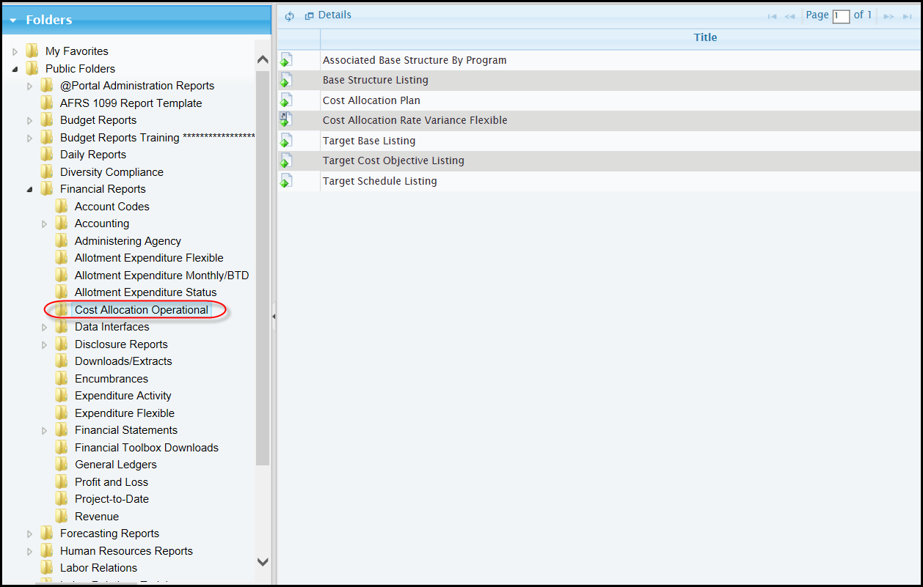

Report Number: CAS357

Title: Associated Base Structure By Program

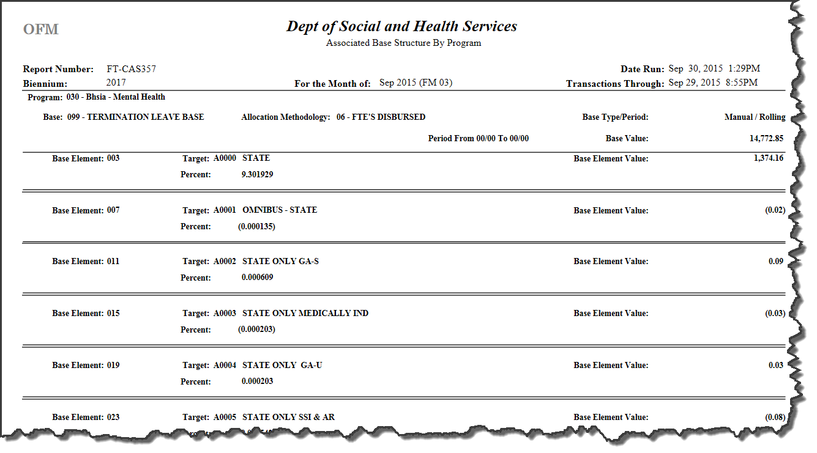

Purpose: Used to review all Base, Element and Sequence information, values and percent by program.

Period: Biennium / Fiscal Month

Sort: Base, Element and Sequence

Report Number: CAS353
Title: Base Structure Listing

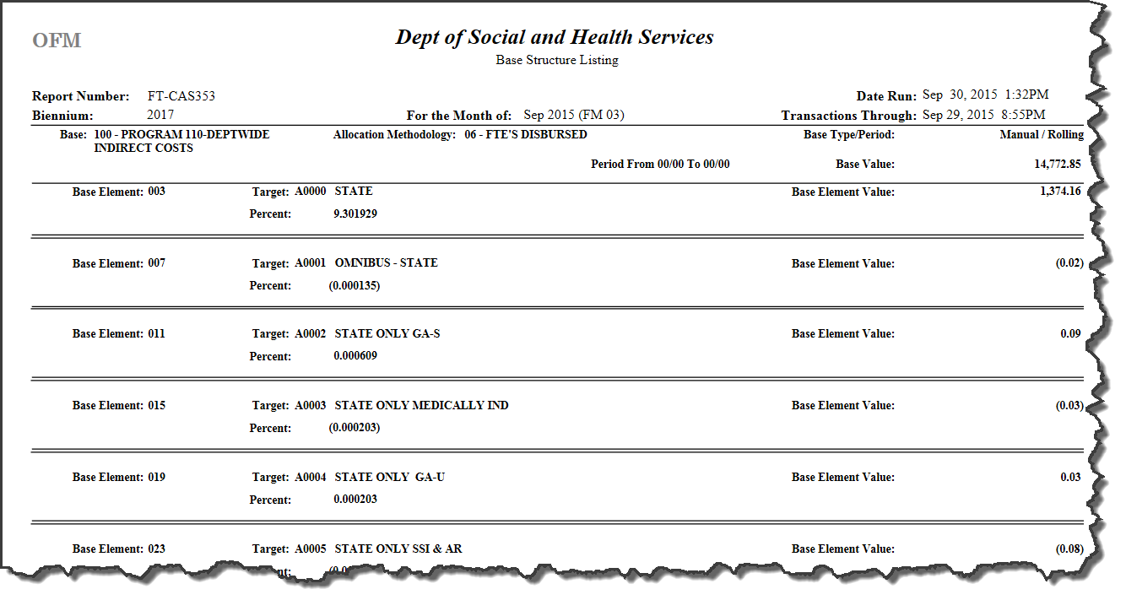
Purpose: Used to review all Base, Element and Sequence information, values and percent. This report identifies errors for target bases that do not exist and inactive cost objectives. Note: This report displays each Base in the Base table, even if the Base is not in the final cost allocation process (Base is not in a Schedule or if the Base is in a Schedule the Schedule is not in a Schedule Link).

Period: Biennium / Fiscal Month

Sort: Base, Element and Sequence

Report Number: CAS371
Title: Cost Allocation Plan

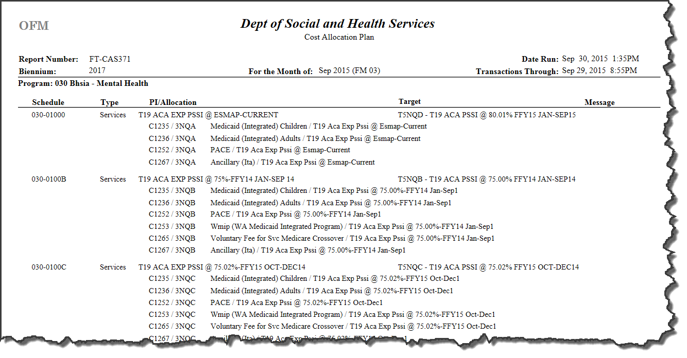
Purpose: Used to review and to monitor the Cost Allocation Plan. This report identifies the correct allocation code to use with a Program Index when coding documents, and to research financial adjustments.

Period: Biennium / Fiscal Month

Sort: Schedule, Program Index and Allocation Code
Break: Program

Report Number: EXF04

Title: Cost Allocation Rate Variance Flexible

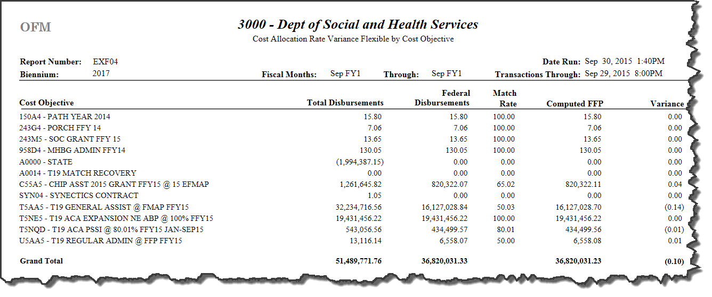

Purpose: Used to review for a period of months the total disbursements and Federal disbursements by cost objective.

Period: Biennium / Fiscal Month

Sort: Cost Objective

Report Number: CAS365
Title: Target Base Listing

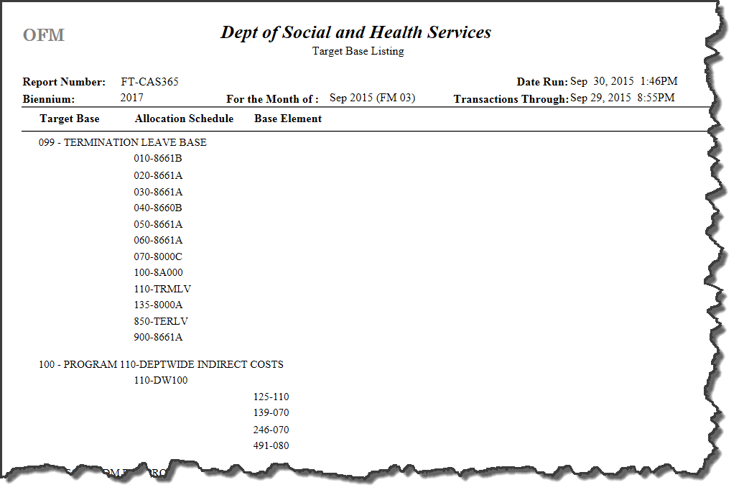

Purpose: Used to identify all the Allocation Schedules(s) and Base Element(s) directed to a base. This report provides information to research adjustments and to monitor the Cost Allocation Plan for possible changes

Period: Biennium / Fiscal Month

Sort: Base, Schedule and Element

Report Number: CAS364

Title: Target Cost Objective Listing

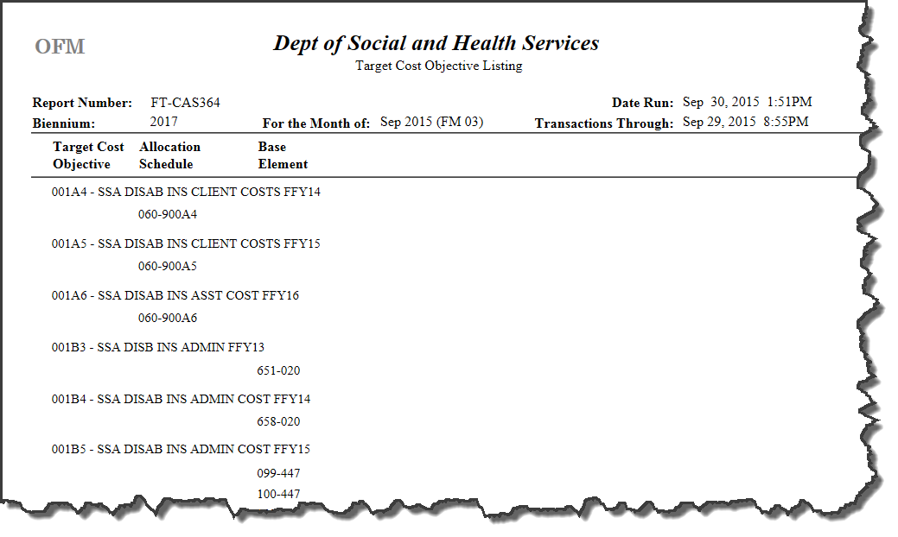

Purpose: Used to identify all the Target Base(s), the allocation schedule and Base Element(s) directed to a base. This report provides information to research adjustments and to monitor the Cost Allocation Plan for possible changes

Period: Biennium / Fiscal Month

Sort: Base, Schedule and Element

Report Number: CAS366
Title: Target Schedule Listing

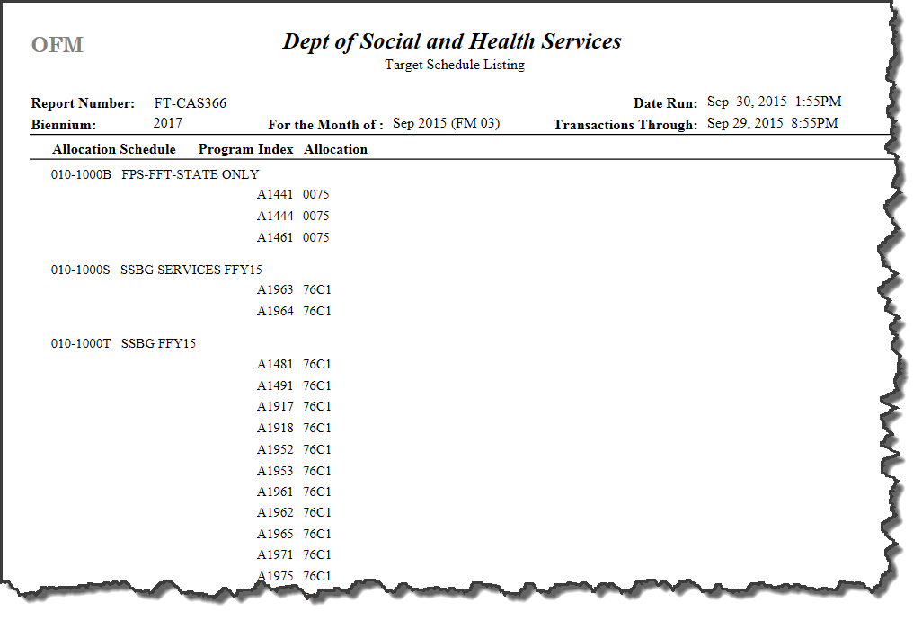

Purpose: Primarily used to manage the Cost Allocation Plan and to identify the Program Index / Allocation Code(s) required for manual adjustments. This report is also used to identify any unnecessary Program Index / Allocation Code combinations.

Period: Biennium / Fiscal Month

Sort: Schedule (program – group), program index and allocation code

Report Number: CAS391

Title: Cost Allocation Plan Table Maintenance (Daily Report-Automatic)

300-0 DEPT OF SOCIAL AND HEALTH SERVICES AGY PAGE: 1
RPT CAS391 COST ALLOCAITON PLAN TABLE MAINTENANCE 15/09/30 (08:54)

FOR THE PLAN OF APRIL 2015 (15/04)

ON SEPTEMBER 30, 2015

TABLE: SCHEDULE

TARGET TYPE TITLE REQUESTED BY UPDATED

050-DMG02 ADD : A0000 B BOO HOO M EE / /

050-DMG03 ADD : AD027 B BOO HOO M EE / /

050-DMG04 ADD : AD027 B BOO HOO M EE / /

TABLE: BASE ---FIXED-

METHOD TYPE PERIOD FROM TO ROLL REQUESTED BY UPDATED

154 DELETE: 02 A F Y D TEST 09/30/15

MY TESTING FOR EDITS

154 ADD: 06 M F 0101 0101 Y U EE 09/30/15

BILL

154 DELETE: 03 M F Y M EE 09/30/15

DUANE

154 ADD: 03 M F Y M EE 09/30/15

DUANE

154 ADD: 02 A F Y M EE 09/30/15

DUANE

154 DELETE: 06 M F 0101 0101 Y M EE 09/30/15

BILL

TABLE: ELEMENT (BASE)

TOTAL VALUE TARGET REQUESTED BY UPDATED

154-010 DELETE: 340.00 A0000 M EE 09/30/15

154-020 DELETE: 200.00 A0000 M EF 09/30/15

154-030 DELETE: 300.00 A0000 M EF 09/30/15

154-050 DELETE: 0.00 201 B PIT 09/30/15

154-079 ADD : 0.00 DUANE D TEST 09/30/15

154-079 DELETE: 0.00 DUANE D TEST 09/30/15

154-010 ADD : 0.00 154 M EE 09/30/15

154-010 DELETE: 100,000.00 154 M EE 09/30/15

154-010 ADD : 100,000.00 154 M EE 09/30/15

154-010 DELETE: 100,000.00 154 M EE 09/30/15

300-0 DEPT OF SOCIAL AND HEALTH SERVICES AGY PAGE: 2
RPT CAS391 COST ALLOCAITON PLAN TABLE MAINTENANCE 15/09/30 (08:54)

FOR THE PLAN OF APRIL 2015 (15/04)

ON SEPTEMBER 30, 2015

TABLE: ELEMENT (BASE)

TOTAL VALUE TARGET REQUESTED BY UPDATED

507-010 DELETE: 7,389,156.00 505 R CASTRO 09/30/15

507-010 DELETE: 7,389,156.01 505 R CASTRO 09/30/15

507-010 DELETE: 7,389,156.01 505 R CASTRO 09/30/15

507-010 DELETE: 7,389,156.00 505 R CASTRO 09/30/15

154-010 DELETE: 0.00 154 09/30/15

154-020 DELETE: -1,934.00 154 R CASTRO 09/30/15

154-020 ADD : -1,934.00 154 R CASTRO 09/30/15

TABLE: SEQUENCE (BASE ELEMENT)

PI ALLC DATA VALUE ADJUSTMENT VALUE REQUESTED BY UPDATED

154-010-010 DELETE: A0000 0010 0.00 100.00 M EE 09/30/15

154-010-020 DELETE: A0000 0010 0.00 110.00 M EE 09/30/15

154-010-040 DELETE: A0000 0010 0.00 120.00 M EE 09/30/15

505-010-010 DELETE: B1151 0010 0.00 0.00 R CASTRO 09/30/15

506-010-010 DELETE: B1513 0010 6,175.18 0.00 R CASTRO 09/30/15

506-010-010 DELETE: B1513 0010 6,175.18 0.01 R CASTRO 09/30/15

506-010-010 DELETE: B1513 0010 6,175.18 0.01 R CASTRO 09/30/15

506-010-010 DELETE: B1513 0010 6,175.18 0.00 R CASTRO 09/30/15

TABLE: SCHEDULE

TARGET TYPE TITLE REQUESTED BY UPDATED

010-DUANE ADD : DUANE A TEST ADD INACTIVE M EE / /

010-DUANE ADD : DUANE A TEST ADD INACTIVE M EE / /

010-DUANE ADD : 154 A TEST ADD INACTIVE D TEST 09/30/15

010-DUANE DELETE: 154 A TEST ADD INACTIVE M EE 09/30/15

010-REB01 ADD : 777F2 S COBJ 777F2 R CASTRO / /

010-REB01 ADD : 777F2 S COBJ 777F2 R CASTRO / /

010-REB01 ADD : DUANE S COBJ 777F2 M EE 09/30/15

Purpose: Used to identify all additions and deletions made to any of the Cost Allocation Plan tables for the open month between the plan on the first of the month and the end of the month. This is the only Cost Allocation Plan report that runs during the open month to identify the allowable updates.

Period: Biennium / Fiscal Month

Sort: Table Name, Table Record and Date of Update

Report Number: CAS611

Title: Schedule Table Roll Exception Report

300-0 DEPT OF SOCIAL AND HEALTH SERVICES AGY PAGE: 1
RPT CAS611 SCHEDULE TABLE ROLL EXCEPTION REPORT 15/05/03 (02:22)
FOR THE MONTH OF MAY 2015 (05/15)

SCHEDULE TITLE TYPE COST OBJ BASE REQUESTED BY LAST UPD WARNING
--------- ------------------------------------- ---- -------- ---- --------------- -------- ------------
050 50170 NON EXISTENT BASE B 595 R CASTRO 11/16/14 BASE NOT ROLLED
050 50180 NON EXISTENT COBJ A NEXIS R CASTRO 11/08/14 COBJ NOT ROLLED
110 FSREM FOOD STAMP REIMBURSEMENT-2014 A E61A1 A LANG / / COBJ INACTIVE
145 FSREM FOOD STAMP REIMBURSEMENT 2014 A E61A1 A LANG / / COBJ INACTIVE

Purpose: Provides a list of schedules (program and group) that have potential errors for the plan build.

Columns:

- schedule,
- group title,
- schedule type (“A” administrative, “S” client services, “B” both),
- target cost objective or base (the schedule links to one cost objective or base),
- last schedule add or change requested by,
- last updated, and
- warning for schedule

Period: Biennium / Fiscal Month

Sort: Schedule (program and group)

Report Number: CAS612

Title: Base Table Roll Exception Report

300-0 DEPT OF SOCIAL AND HEALTH SERVICES AGY PAGE: 1
RPT CAS612 BASE TABLE ROLL EXCEPTION REPORT 15/05/03 (02:22)
FOR THE MONTH OF MAY 2015 (05/15)
ALLOC PERIOD

BASE TITLE METH TYPE TYPE FROM TO ROLL USED BASE TOTAL REQUESTED BY LAST UPD
---- -------------------------------- ---- ---- ---- ---- ---- ---- ---- ---------------- ------------ --------
517 SURVEYORS 02 M R 0315 0315 N Y 11,158.50 R CASTRO 03/16/15

Purpose: Provides a list of bases that did not roll. If a base does not roll the associated elements and sequences do not display on the Base Element Table Roll Exception Report – CAS613 or on the Sequence Table Roll Exception Report – CAS614.

Columns:

- base number,
- base title,
- allocation methodology,
- type (‘A’ automated, ‘M’ manual),
- period type (‘F’ fixed, ‘R’ rolling),
- from (biennium / fiscal month),
- to (biennium / fiscal month),
- roll base to fiscal month (‘Y’ yes, ‘N’ no),
- used base [biennium / fiscal month] in the plan ‘Y’ yes, ‘N’ no, if ‘Y’ cannot delete (relates also to element and sequence),
- base total, real time sum of the base elements,
- last base add or change requested by, and
- last updated

Period: Biennium / Fiscal Month

Sort: Base number

Report Number: CAS613

Title: Base Element Table Roll Exception Report

300-0 DEPT OF SOCIAL AND HEALTH SERVICES AGY PAGE: 1
RPT CAS613 BASE ELEMENT TABLE ROLL EXCEPTION REPORT 15/05/03 (02:22)
FOR THE MONTH OF MAY 2015 (05/15)
COST TARGET

BASE ELEMENT OBJ. BASE ELEMENT VALUE PERCENT REQUESTED BY LAST UPD WARNING
---- ------- ----- ---- -------------- ------------------ ---------------- -------- --------------------
523 010 517 1,176.00 65.8454647256400 D GALLAHER 03/16/15 TRGT BASE NOT ROLLED
528 060 517 5.50 29.0237467018400 D GALLAHER 03/16/15 TRGT BASE NOT ROLLED
582 020 RIC11 1.00 14.2857142857100 D GALLAHER 03/16/15 COBJ INACTIVE
584 010 595 6.00 85.7142857142800 D GALLAHER 03/16/15 TRGT BASE NOT ROLLED
604 020 INACT -969,303.79 -1.4529718296400 D GALLAHER 03/16/15 COBJ INACTIVE

Purpose: Provides a list of base elements that have potential errors for the plan build. If a base did not roll, the base displays on the Base Table Roll Exception Report – CAS612, and the associated elements for that base do not display on this report.

Columns:

- base,
- element,
- target cost objective or base
- element value,
- element value percent,
- last element add or change requested by,
- last updated, and
- warning for base element

The base element links to one cost objective or base.

Period: Biennium / Fiscal Month

Sort: Base and Element

Report Number: CAS614

Title: Sequence Table Roll Exception Report

300-0 DEPT OF SOCIAL AND HEALTH SERVICES AGY PAGE: 1
RPT CAS614 SEQUENCE TABLE ROLL EXCEPTION REPORT 15/05/03 (02:22)
FOR THE MONTH OF MAY 2015 (05/15)
PROGRAM ALLOC ADJUSTMENT

BASE ELEMENT SEQ INDEX CODE DATA VALUE VALUE REQUESTED BY LAST UPD WARNING
---- ------- --- ----- ---- ----------------- ------------------ ---------------- -------- -------------

Purpose: Provides a list of base element sequences that have potential errors for the plan build. If a base did not roll, the base displays on the Base Table Roll Exception Report – CAS612, and the associated sequences for that base do not display on this report.

Columns:

- base,
- element,
- sequence,
- program index,
- allocation code,
- data value (system entered),
- adjustment value (user entered),
- last sequence add or change requested by,
- last updated, and
- warning for base element sequence

The base element sequence(s) is used for an automated base.

Period: Biennium / Fiscal Month

Sort: Base, Element and Sequence

Report Number: CAS616

Title: Cost Objective Roll Exception Report

300-0 DEPT OF SOCIAL AND HEALTH SERVICES AGY PAGE: 1
RPT CAS616 COST OBJECTIVE TABLE ROLL EXCEPTION REPORT 15/05/03 (02:22)
FOR THE MONTH OF MAY 2015 (05/15)

COST P E R C E N T A G E S REVENUE SOURCE INACT OVER

BY OBJ TITLE FEDERAL STATE LOCAL GRP SRC SUBSRC BI/FM RIDE USED REQUESTED BY LAST UPD
-- ----- --------------------------------- ------- ------- ------- -- --- ------ ----- ---- ---- ---------------- --------
03 AAAA0 TITLE TEST X 0.00 100.00 0.00 1510 Y B PRUETT 03/15/15
03 AD027 TXIX SW SINGLE AUDIT FY14 70.00 30.00 0.00 01 51 AAAAAA 1512 N B PRUETT 03/15/15
03 INACT INACTIVE COST OBJECTIVE FOR FM10 0.25 99.75 0.00 03 93 USAA20 1510 N R CASTRO 03/15/15
03 RIC11 INACTIVE COST OBJECTIVE FOR FM11 0.00 100.00 0.00 1511 N R CASTRO 03/15/15

Purpose: Provides a list of cost objectives that did not roll.

Columns:

- biennium,
- cost objective,
- cost objective title,
- percentages: federal, state, local,
- revenue source: major group, major source and sub source,
- biennium / fiscal month to inactive the cost objective (do not include in the plan or do not allow a transaction containing the cost objective to process in AFRS),
- override inactive (allow a transaction containing the cost object to process in AFRS), override has no impact on including the cost objective in the plan,
- used (cost objective is in a financial transaction ‘Y’ yes, ‘N’ no), if ‘Y’ cannot delete, or change percentages or revenue source,
- last cost objective add or change requested by, and
- last updated

Period: Biennium

Sort: Biennium and Cost Objective

Report Number: CAS617

Title: Schedule Link Roll Exception Report

300-0 DEPT OF SOCIAL AND HEALTH SERVICES AGY PAGE: 1
RPT CAS617 SCHEDULE LINK TABLE ROLL EXCEPTION REPORT 15/05/03 (02:22)
FOR THE MONTH OF MAY 2015 (05/15)
PROGRAM ALLOC

INDEX CODE SCHEDULE ROLL REQUESTED BY LAST UPD WARNING
----- ---- --------- ---- ---------------- -------- -------
C4325 0010 030 4000A Y D SYSTEM / / PI INACTIVE

H8511 0010 080 A10BA Y D SYSTEM / / PI NOT FOUND

K2411 FSNR 110 FSREM N A LANG / / NOT ROLLED

N7411 FSNR 145 FSREM N A LANG / / NOT ROLLED

N9111 9999 145 SUSPZ Y D SYSTEM / / PI INACTIVE

P9351 0010 150 9000A Y D SYSTEM / / PI INACTIVE

P9532 0010 150 9000A Y D SYSTEM / / PI INACTIVE

Purpose: Provides a list of schedule links that did not roll or that have potential errors for the plan build.

Columns:

- program index,
- allocation code,
- schedule,
- roll schedule link to next fiscal month (‘Y’ yes, ‘N’ no),
- last schedule link add or change requested by, and
- last updated

The program index / allocation code links to one schedule.

Period: Biennium / Fiscal Month

Sort: Program Index and Allocation Code

Report Number: CAS619

Title: Appropriation Index Crosswalk Exception Report

300-0 DEPT OF SOCIAL AND HEALTH SERVICES AGY PAGE: 1
RPT CAS619 APPROPRIATION INDEX CROSSWALK EXCEPTION REPORT 15/05/03 (02:22)

APPN CROSSWALK INDEXES

BY INDEX PROGRAM TITLE FEDERAL STATE LOCAL REQUESTED BY LAST UPD
-- ----- --------- --------------------------------- ------- ----- ----- ---------------- --------

Purpose: Provides a list of appropriation index crosswalk records that did not roll.

Columns:

- biennium,
- appropriation index,
- program and title,
- crosswalk indexes federal, state and local,
- last schedule link add or change requested by, and
- last updated

Period: Biennium

Sort: biennium/appropriation index

Appendix A – Batch Job Submission Screen

Batch Job Submission

=== AFRS =(TM.3.7)========== BATCH JOB SUBMISSION ================ C105U100 ===

3000

PRINT AGENCY CONTROLS

------------------------------- JOB PARAMETERS -------------------------------

CLASS: _ (H=HOT, A=PRIORITY, D=TODAY, E=TONIGHT, C=SCHED)

CONTACT: ____________________ (PERSON OUTPUT IS DIRECTED TO)

SEND OUTPUT TO: _________ (LOCAL, R###, CLUSTER ID, EXCHANGE, IOF)

BIN NUMBER: __

LOCATION: __

LOGONID: _______ COPIES: __ PRINT JCL: N(Y OR N)

JOB ID: ___ (FIRST 3 CHARACTERS OF JOB NAME)

(ENTER=SUBMIT, F3=RETURN, F12=MESSAGE, CLEAR=EXIT)

CHANGE THE DEFAULT VALUES AS NEEDED AND PRESS ENTER TO SUBMIT THE BATCH JOB.

Purpose: Provides capability to view / download / print from the mainframe.

Job Parameters

When you select function P (Print) on any of the AFRS screens, the Batch Job Submission screen will be displayed. The input fields will display the last entries used by the current Logon ID. If the fields displayed are correct, press [Enter]. If you want to change any of the options, do so before pressing [Enter]. The fields are as follows:

�� Class determines the priority given to your job. REQUIRED – 1 character.

Generally select job class D. Job class H and A is more expensive. Job class E is less expensive, but runs overnight.
Job class C is for extremely large reports that time out under the other job classes

H = HOT, fastest turnaround but use with caution (size and time parameters may cause job to abend)
A = Two hours (for short reports, quick turnaround)
D = Four hours (for longer reports)
E = Overnight (for lengthy or detail reports)
S = Extremely large jobs or reports that time out

 Contact is the person’s name that will appear on the first page of the report run which may be used for distribution purposes. You may want to include mail stop.

 Send Output To indicates where and how the report is to be printed. REQUIRED – up to 9 characters.

Local = Page Printer (Department of Enterprise Services – Production Services)
R### = Agency’s own remote printer number (R + 2 or 3 digits)
######## = Agency’s own cluster printer number (up to 8 digits)
IOF = Interactive Output Facility in Time Share Option (TSO) where report may be viewed or cancelled prior to printing
Exchange = Exchange File Output creates an exchange dataset in TSO which can be browsed, edited or downloaded to your PC. Exchange files are available to work with in TSO for three calendar days after submission.

 � Bin Number is no longer available. To get the your report mailed to you, use bin # 00 and type a mail stop in the contact field or use the location code field (below). REQUIRED – 2 digits.

 � Location is an optional code which must be established on the Mailing Label/Banner Page Maintenance screen (RR.3) and will override the bin number above for delivery address of your report. Note: The bin number on screen RR.3 must be blank if you want report(s) delivered to the address (i.e. mail stop) listed on that screen. OPTIONAL – 2 characters.

  Logon ID of person submitting report.

  OR –

If the report is to be held in IOF or as an exchange dataset, enter the Logon ID of the person viewing the output in TSO. REQUIRED – 7 characters.

 � Copies is the number of copies of the report you wish to receive. REQUIRED – 2 digits.

  - Print JCL Type Y (Yes) to print or N (No) to suppress printing of the job code language (JCL) used by programmers for troubleshooting. Since the JCL is quite lengthy for these reports, it is recommended you do not print the JCL. If you have trouble with a report, you can submit it again and request the JCL so our programmers can locate the problem.

� Job ID is the first three characters of the job name and can be used to locate a specific job in TSO. System will default to the initials of the logon id. REQUIRED: position 1 = alpha; positions 2 and 3 = alphanumeric).

Appendix B – Cost Allocation Transaction Codes

Transaction Code Selection For Cost Allocated Transactions Based on General Ledger Account and Amount Sign

CA General Ledger Account Fund Cash Type | Fiscal Month | Amt | Object | IFT TC | No IFT TC | TC General Ledger Accounts
6510 Cash Expenditures ($)
Not Local Funds | 01 – 24 | > 0 |  | 669 | 263 | 6510 / 7140
 | 01 – 24 | < 0 |  | 670 | 264 | 7140 / 6510
 | 99 / 25 | > 0 |  | 345 |  | 6510 / 9920
 | 99 / 25 | < 0 |  | 346 |  | 9920 / 6510
Local Funds | All | > 0 |  |  | 941 | 6510 / 1110
 | All | < 0 |  |  | 942 | 1110 / 6510
51xx Liquidations ($)
Not Local Funds | 01 – 24 | > 0 | A or B | 103 | 833 | 5124V / 7140
 | 01 – 24 | < 0 | A or B | 106 | 833 R | 7140 / 5124V
 | 01 – 24 | > 0 |  | 103 | 833 | 5111V / 7140
 | 01 – 24 | < 0 |  | 106 | 833 R | 7140 / 5111V
 | 99 / 25 | > 0 | A or B | 019 |  | 5124V / 9920
 | 99 / 25 | < 0 | A or B | 084 |  | 9920 / 5124V
 | 99 / 25 | > 0 |  | 019 |  | 5111V / 9920
 | 99 / 25 | < 0 |  | 084 |  | 9920 / 5111V
Local Funds | All | > 0 | A or B |  | 831 | 5124V / 1110
 | All | < 0 | A or B |  | 831R | 1110 / 5124V
 | All | > 0 |  |  | 831 | 5111V / 1110
 | All | < 0 |  |  | 831R | 1110 / 5111V
6505 Accrued Expenditures ($)
All Funds | All | > 0 | A or B | NO | 224 | 6505 / 5124
 | All | < 0 | A or B | NO | 224 R | 5124 / 6505
 | All | > 0 |  | NO | 736 | 6505 / 5111
 | All | < 0 |  | NO | 736 R | 5111 / 6505
6410 Encumbrances ($)
All Funds | All | > 0 |  | NO | 735 | 6410 / 9510
 | All | < 0 |  | NO | 735 R | 9510 / 6410

0120 FTEs Actual
All Funds | All | > 0 |  | NO | 894 | 0120 / 0998
 | All | < 0 |  | NO | 895 | 0998 / 0120
0140 FTEs Liquidations
All Funds | All | > 0 |  | NO | 892 | 0140 / 0998
 | All | < 0 |  | NO | 893 | 0998 / 0410
0130 FTEs Accrued
All Funds | All | > 0 |  | NO | 898 | 0130 / 0998
 | All | < 0 |  | NO | 899 | 0998 / 0130
Local Fund is cash type ‘3’ on Fund descriptor table D22
IFT is inter-fund transfer. IFT eliminates the agency prepared paper journal voucher to the State Treasurer.

If cost allocated transaction fund does not equal input transaction fund and transaction fiscal month is 99 / 25 and it is a current disbursement general ledger account 6510 or prior liquidation general ledger account 51xx see chart below for additional transactions required. The additional transactions include only the following account code elements: Fund, Program Index (Last 4 characters of Program Index are 0000) and Subsidiary Account.

Transaction Codes to complete Inter-Fund transfer in fiscal month 99 / 25. Build one transaction from each transaction type when the cost allocated transaction fund does not equal the input transaction fund.

If cost allocated transaction with the cost allocated fund is a debit to GL Acct 6510 or 51xx (amount is positive)
Trans Type | Input FM | Output FM | Output Bien | Tran Fund | IFT TC | GL Accts | Subsidiary Account
Due From | 99 / 25 | 99 / 25 | Input | Input | 348 | 1353V / 9920 | Cost Alloc Fund DR
Due To | 99 / 25 | 99 / 25 | Input | Cost Alloc | 347 | 9920 / 5153V | Input Fund CR
Liq Due From | 99 / 25 | Current | Current | Input | 026 | 7140 / 1353V | Cost Alloc Fund CR
Liq Due To | 99 / 25 | Current | Current | Cost Alloc | 025 | 5153V / 7140 | Input Fund DR
If cost allocated transaction with the cost allocated fund is a credit to GL Acct 6510 or 51xx (amount is negative)
Trans Type | Input FM | Output FM | Output Bien | Tran Fund | IFT TC | GL Accts | Subsidiary Account
Due From | 99 / 25 | 99 / 25 | Input | Cost Alloc | 348 | 1353V / 9920 | Input Fund DR
Due To | 99 / 25 | 99 / 25 | Input | Input | 347 | 9920 / 5153V | Cost Alloc Fund CR
Liq Due From | 99 / 25 | Current | Current | Cost Alloc | 026 | 7140 / 1353V | Input Fund CR
Liq Due To | 99 / 25 | Current | Current | Input | 025 | 5153V / 7140 | Cost Alloc Fund DR

Appendix C – Determine Allocation Plan

 |  |  | Cost Allocation Plan
Transaction Type | General Ledger | Posting Fiscal Month | Current | Prior | FM 12 or  FM 24
Disbursement | 6510, 51xx, 0120,  or 0140 | Current Fiscal Month | X
 |  | Prior Fiscal Month |  | X
 |  | FM 99 or FM 25 |  |  | X
Accrual / Encumbrance | 6505, 0130, or  6410 | Current or Prior Fiscal Month | X
 |  | FM 12 or FM 24 |  |  | X
 |  | FM 99 or FM 25 |  |  | X

How to use the Determine Allocation Plan Table
Determine the general ledger accounts embedded in the transaction code. If the transaction code contains none of the general ledger accounts listed in the chart, then that transaction code is not cost allocated. A transaction code can contain zero, one or two of the general ledger accounts listed in the chart. Do not use 51xx if the transaction code also contains 6505 or 6510.
Find the general ledger account under the column heading General Ledger. The fiscal month on the transaction is the posting fiscal month.
Select the cost allocation plan from the last three columns depending on the selection in the second and third columns.

Appendix D – Glossary

Term | Description
Accrued | Goods or services received, but not paid for at the end of the accounting period.
Base | The first level in the base hierarchical structure; below the base is the base element. An intermediary cost pool. A base uses one of the federally approved methodologies to distribute costs between cost objectives.
Base Element | The second level in the base hierarchical structure; below the base element is the base element sequence. The element contains a target base or cost objective. The element also contains a value for the base methodology. The value is converted to a percent that applies to the target base or cost objective. Through the plan build the target base is converted to cost objectives. Each cost objective receives a percent of the base percent. The sum of the cost objective percent’s in a base is 100 percent.
Base Element Sequence | The third level in the base hierarchical structure. Used only for automated bases. Each sequence has a program index / allocation code combination that retrieves a value for a fiscal month. The sequence can also contain an adjustment value that is manually entered. The element value is the sum of the sequence values.
Cost Allocation | Creating cost allocation tables that are used to build an automated cost allocation plan. Selecting AFRS financial transitions, merging as financial data to apply the cost objective(s), the cost objective’s federal, state and / or local share, and the proper appropriation index.
Cost Objective | A federal grant, part of a federal grant or a state funded program. A cost objective has a federal, state and / or local share.
Disbursement | A payment. In the cost allocation system a disbursement is represented by general ledger accounts 6510 or 51xx for dollars and 0120 or 0140 for FTEs.
General Ledger Account | A four-digit code that represents an asset, liability or equity and includes budgetary and FTEs.
IFT | IFT is inter-fund transfer. IFT automatically creates the journal voucher to the State Treasurer and eliminates the agency prepared paper journal voucher to the State Treasurer.
Liquidation | Payment of a liability, receipt of a receivable, or reduction of an encumbrance.
Maintenance | Another term for ‘Update’
Methodology | A federally approved distribution method applied to a base.
Update | A term that encompasses add, change and delete.

Appendix E – Viewing AFRS Reports Online before Printing

Using IOF (Interactive Output Facility)
in TSO (Time Share Option) Region

If you use the P(Print) function on the AFRS CAS Tables screens or the Reports screen and press [Enter] a Batch Job Submission screen will appear. On this screen, if you use IOF in the Destination field AND you have access to TSO, you may view your AFRS reports in the Interactive Output Facility. Once you view the reports, you can decide to print them to a specific printer or cancel them.

- After logging into the mainframe you will be on the TPX Menu. Look under the Session ID (SESSID) to see if you have a TSOV1 selection. You can either type TSOV1 on the command line or enter an “S” next to the line and press [Enter].

- The next screen default to your User ID, with the cursor on the field for Password. Type your Password and press [Enter].

- A WELCOME TO TSO screen will appear. When three asterisks (***) appear, press [Enter].

ICH70001I DTAC105 LAST ACCESS AT 13:04:48 ON FRIDAY, OCTOBER 2, 2015
DTAC105 LOGON IN PROGRESS AT 13:28:38 ON OCTOBER 2, 2015
# # # # # # # # # # # # # # # # # # # # # # # # #
Welcome to the State of Washington
TSO session running under z/OS Version 1.13
# # # # # # # # # # # # # # # # # # # # # # # # #

***

- The CONSOLIDATED TECHNOLOGY SERVICES: MAIN MENU will be displayed. At the Select Option field, type =I. (IOF) and press [Enter].

Consolidated Technology Services: Main menu
Select option ===> I.

Systems Utilities October 2015
Foc Focus F Fileaid Su Mo Tu We Th Fr Sa
Sas SAS P IPT OLISTs 1 2 3
E Endevor V View/edit datasets 4 5 6 7 8 9 10
Pdf ISPF/PDF T TSO command shell 11 12 13 14 15 16 17
I IOF O Other utilities 18 19 20 21 22 23 24
S Storage U Private utilities 25 26 27 28 29 30 31

X = Exit to READY
XL= Exit and LOGOFF

Prefix XXXX105 User XXXX300 Date 15.275 Time 13:34
F1=HELP F2=SPLIT F3=END F4=RETURN F5=RFIND F6=RCHANGE
F7=UP F8=DOWN F9=SWAP F10=LEFT F11=RIGHT F12=RETRIEVE

- This will bring up the IOF USER OPTION MENU. (See Figure 1.9). Cursor down to the JOBNAMES field and type your 8-digit Job Name which appeared on the Batch Job Submission screen when you submitted your job. The Job Name will normally consist of 8 characters: XXXFS300 where XXX = the 3 characters you chose for the Job ID on the Batch Job Submission screen.

------------------------------- IOF Option Menu -------------------------------
COMMAND ===>

Follow an option with "?" to display its detailed interface panel.

blank - Your jobs MORE - More Cmds
I - Input jobs
R - Running jobs
O - Output jobs
J - Jobs menu
G - Output Groups
H - Held Groups
P - IOF Profile

JOBNAMES ===> XXXFS300
Enter 1 to 8 generic jobnames above

SCOPE ===> ALL, ME or another user's USERID
DEST ===>
Enter 1 to 8 destinations above

F1=HELP F2=SPLIT F3=END F4=RETURN F5=RFIND F6=RCHANGE
F7=UP F8=DOWN F9=SWAP F10=LEFT F11=RIGHT F12=RETRIEVE
You can use wild card characters (+ for one character and * for any number of characters). For example, if you know the first character of all your reports is N, you can type N* and press [Enter]. All completed jobs that start with N will be listed on the next screen. If you want to limit your search to only Jobs that reports that start with N, you would type in N++FS300.. Press [Enter].

- The next screen, IOF JOB LIST MENU, will display the reports that meet the parameters you defined if there is more than one report. (If there is only one report, this step will be skipped.) To select a job to view, either type the line number on the COMMAND line -- OR -- cursor to the line you want to select and type S (Select) to the left of the line number. Press [Enter]. (See Figure 2.0)

------------------------------ IOF Job List Menu -------------( 4 )------------
COMMAND ===> SCROLL ===> SCREEN
--------------------------------- Output Jobs ---------------------------------
-------JOBNAME--JOBID---ACT-STAT-OWNER----DEST/DEVICE-------RECS-HELD-DAY--TIME
_ 1 XXXFS300 J039145 4 XXXX300 IOF 229 272 7:48
_ 2 XXXFS300 J049791 4 XXXX300 IOF 229 273 7:36
_ 3 XXXFS300 J001130 4 XXXX300 R70 229 274 8:49
_ 4 XXXFS300 J013694 4 XXXX300 R70 229 275 8:53

- This will bring up the IOF JOB SUMMARY screen. (If there was only one job that met your parameters, the IOF JOB SUMMARY screen will appear without displaying the IOF JOB LIST MENU.)

------------------------------- IOF Job Summary -------------------------------
COMMAND ===> SCROLL ===> SCREEN
--JOBNAME--JOBID----STATUS---RAN/RECEIVED------DAY-------DEST------------------
XXXFS300 J054878 OUTPUT 15:33 9/30/2015 TODAY IOF
--RC--PGM--------STEP-----PRSTEP---PROC-----COMMENTS---------------------------
0 MAKEFILE MAKE01 STEP01 MAKERPT
0 WPD900P WPD900P1 STEP01 WPD900P
0 ODBILL CICSPRN1 CICSPRN CICSPRN
--------DDNAME---STEP-----STAT-ACT-C-GRP-FORMS----D-SIZE-U-DEST----------------
_ 1 LOG * DONE X 0001 15 L
_ 2 JCL * DONE X 0001 212 L
_ 3 MESSAGES * DONE X 0001 89 L
_ 4 SYSOUT MAKE01 DONE X 0001 5 L
_ 5 SYSUDUMP MAKE01 DONE X 0001
_ 6 SYSOUT WPD900P1 DONE X 0001 8 L
_ 7 SYSUDUMP WPD900P1 DONE X 0001
_ 8 ABNLDUMP WPD900P1 DONE X 0001
_ 9 SYSOUT CICSPRN1 DONE X 0001 21 L
s 10 REPORT CICSPRN1 X 1 0001 W 1026 L IOF

F1=HELP F2=SPLIT F3=END F4=RETURN F5=RFIND F6=RCHANGE
F7=UP F8=DOWN F9=SWAP F10=LEFT F11=RIGHT F12=RETRIEVE

You need to get to the last line of coding which has the word REPORT in it. To do this, press [PF8] several times until you get to the last screen -- OR -- type M (Maximum) on the COMMAND line and press [PF8] once.

- To display your report, type the line number which shows REPORT on the COMMAND line -- OR -- cursor down to the last line which has the word REPORT in it and type an S (Select) in the first column. Press [Enter].

- Press [PF8] several times to scroll down to the first page of the first report. You can scroll around the report using the following PF Keys:

PF7 = Scroll Backward PF8 = Scroll Forward PF10 = Scroll Left
PF11 = Scroll Right

You can also move to a specific page or line number by typing it on the COMMAND line. (For example, Page 16 --OR-- Line 40)

- When you are finished inspecting the report, press [PF3] once or twice, until you return to the IOF JOB LIST MENU. On this screen you may use the commands below by typing them in the left-hand column of the line you wish to change. Only one command at a time and for only one job number at a time will be accepted.

------------------------------ IOF Job List Menu -------------( 4 )------------
COMMAND ===> SCROLL ===> SCREEN
--------------------------------- Output Jobs ---------------------------------
-------JOBNAME--JOBID---ACT-STAT-OWNER----DEST/DEVICE-------RECS-HELD-DAY--TIME
_ 1 XXXFS300 J039145 4 XXXX300 IOF 229 272 7:48
P 2 XXXFS300 J049791 4 XXXX300 LOCAL 229 273 7:36
_ 3 XXXFS300 J001130 4 XXXX300 R70 229 274 8:49
_ 4 XXXFS300 J013694 4 XXXX300 R70 229 275 8:53

C = Cancel the report. If not canceled or printed, it will remain in IOF for six calendar days.)
P + Printer Name in DEST/DEVICE column = Print at named printer location. This can be LOCAL for DES Print services or your agency’s remote printer. (Cluster printer numbers will not work on this screen.)
S = Select to view your report again.

- To back up to a previous screen, press [PF3].

- To logoff, you will need to F3 back to the Main Menu. Type = XL in the Select Option line and press [Enter].

