

Technology Services Division
ENTERPRISE REPORTING
Introduction to the Exercise 1: Creating and saving a query

July 2012

Table of Contents

In-Class Exercises 4
Exercise 1: Creating and saving a basic query. 4
Exercise 2: Combining Filters 9
Exercise 3: Simple Calculation 11

In-Class Exercises

Exercise 1: Creating and saving a basic query.

Overview:
In this exercise, we will practice making a basic query and saving to your “Favorites” folder.
- From the home screen, click on.
- Click on located in the upper left hand corner to create a new query. This will activate a drop down list. From the list choose
- The Universe selection screen will be displayed. Choose the universe named ‘AFRS 2011’.
- The Edit Query screen will be displayed.
- Double click the following objects into your ‘Results Objects’ section.
Name of Object | Object’s Class
Fiscal Month | Time Class
GL Account | GL Account Class
GL Account Title | GL Account Class
Account | Account (Fund) Class
Object | Object Class
Object Title | Object Class
Amount | Measure Class

- Drag and drop the following objects into your 'Query Filter' section.
Name of Object | Object’s Class
Agency | Agency Class
Fiscal Month | Time Class
GL Account | GL Account Class

- Click on the creating query icon within the ‘Agency’ query filter: Click on the “Value(s) from List” selection.

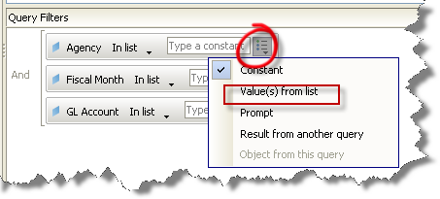
- A dialog box will be displayed with a “List of Values”. You can complete one of the following steps to find your specific agency. These steps can be completed for any parameter list within Web Intelligence.

  - Type the three digit number of your agency in the upper left hand corner and click on the green arrow to put this into the parameter box.
  - Using the scroll bar within the list, find your agency, and double click on the selection.
  - Type your agency in the search field and click on the binoculars icon to the right and click on the green arrow to put this into the parameter box.
When you are done, click on the ‘OK’ button.

- From the "Fiscal Month" object in the 'Query Filter' section, click on the creating queries drop down box.

- Click “Value(s) from list”

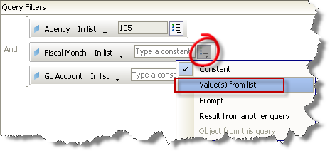
- Highlight a value in the Fiscal Month box

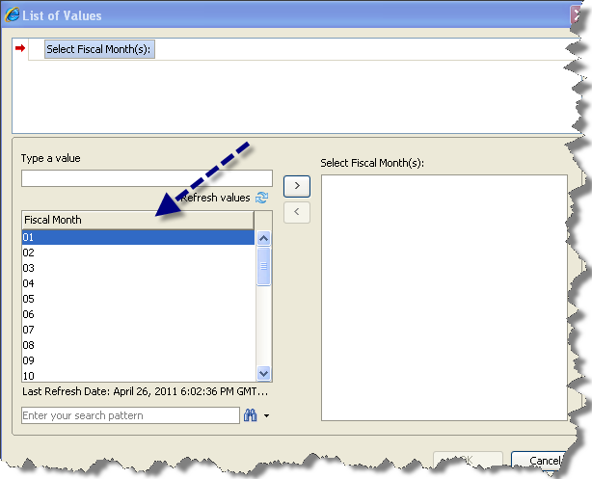

- Type “1”
- The system will navigate to the first instance of “1” in the list.

- Select Fiscal Month “12”
- Click the arrow right

- Click OK

- From the "GL Account" object, click on the creating queries drop down box.

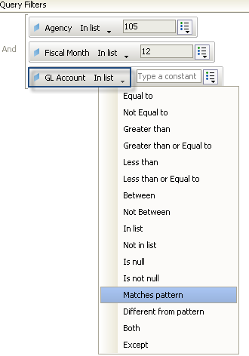

- Select “Matches pattern”

- From the GL Account object, enter “65%”. (Note: We use percent sign as the special characters to matches pattern like 65%).

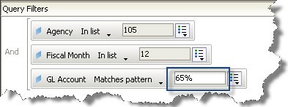

- In the upper right hand corner of the screen click on this icon: This will run the query.

- The Edit Report screen will be displayed. In the upper left hand corner of the Edit Report screen, click on the Save icon (Save as).

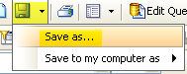

- The save dialog box will be displayed. Type “Exercise 1 – Basic Query” in the title field. Notice that the default folder for this saved query is ‘Favorites’. Click on the OK button when you are complete.

- Click on the Document X to close out of Web Intelligence document

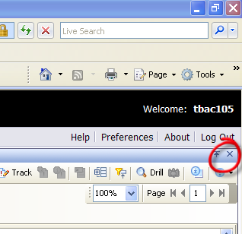

To view saved query

- In the Folders section, if it is already not expanded, click on the plus sign next to ‘My Favorites’. This will display all of your saved queries.

- You should see a new query named “Exercise 1 – Basic Query” with your general description narrative.

- Click on the title “Exercise 1 – Basic Query”. This will display your query in Document view.

Another way to edit a query is through the “Edit” of the document

- In the upper left hand corner of the report screen, click on the ‘Document’ icon. A drop down list will appear. Click on ‘Edit’.

Toggle between “Edit Report” and “Edit Query”

- The report view of the report will be displayed. In your upper left hand corner of the report page, click on to display the ‘Edit Query’ screen.

- At the top of the query editor screen click on the ‘Edit Report’ tab. This will display the ‘Edit Report’ screen.

- In the upper right hand corner of the Edit Report screen, click on the small x to close this query without saving.

Note: If you do not have a small x and you are viewing a report, you can click on large X. This will close the query you are viewing.

- In the upper left hand corner of the screen, click on this icon: This will direct you to the Web Intelligence home screen.

End of Exercise

Exercise 2: Modifying and combining queries

Overview:
In this exercise, we will practice modifying a saved query.

- In the Folders section, if it is already not expanded, click on the plus sign next to ‘My Favorites’. This will display all of your saved queries.

- You should see a new query named “Exercise 1 – Basic Query”.

- Right Click and select Modify “Exercise 1 – Basic Query”. This will display the "Edit Report" screen.

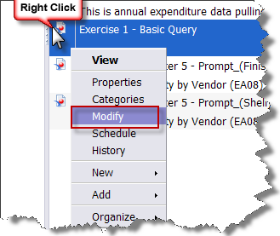
- In your upper left hand corner of the report page, click on to display the ‘Edit Query’ screen.

Steps 5 – 9 will show you how to create combining filters (a nested query) that will display fiscal month 01 through 12 and fiscal month 99 expenditures for your agency:

- Click on the drop down box found in the middle of the ‘Fiscal Month’ query filter. A drop down box with a list of operators will be displayed. Click on the selection criteria named ‘Between’.

- Your query filter will now be displayed with two parameter fields:

    - In the first query field, type: 01
    - In the second query field, type: 12

- Find ‘Fiscal Month’ in your "Data" Section. Click and drag this object down to your "Query Filter" section. Drag this object over the existing ‘Fiscal Month’ so that the object looks similar to this and release your mouse.

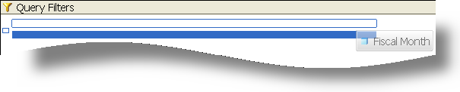
- In the new ‘Fiscal Month’ parameter field, type: 99

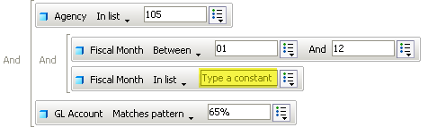

- Double click on the ‘And’ next to new ‘Fiscal Month’ parameter to change it to ‘Or’



- In the upper right hand corner of the screen click on to run the query.

- The "Edit Report" screen will display. In the upper left hand corner of the "Edit Report" screen, click on the Save icon (Save as).

- The save dialog box will displayed. Type “Exercise 2 –Combining Queries” in the title field. Notice that the default folder for this saved query is "Favorites'. Type a small narrative in the general description field. Click on the OK button when you are complete.

- In the upper right hand corner of the Edit Report screen, click on the small x to close this query.

Note: Ok to click on large X if you are in a query.
- In the upper left hand corner of the screen, click on this icon. This will direct you to the Web Intelligence home screen.

End of Exercise

Exercise 3: Simple Calculation
Overview:
In this exercise, we will practice simple calculation.

- Open your Favorites folder and click on the ‘Modify’ hyperlink under the “Exercise 2 – Combining Queries” that was created in previous exercise.

- The Edit Report screen will be displayed.

- Click any data field within your ‘Amount’ column. The column should be gray.

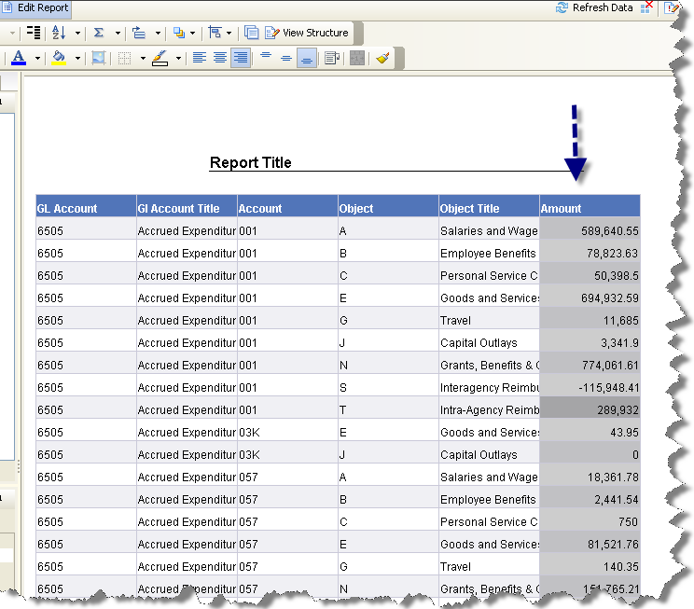

- In the middle of the Report view toolbar, click on the icon to sum the ‘Amount’ column.

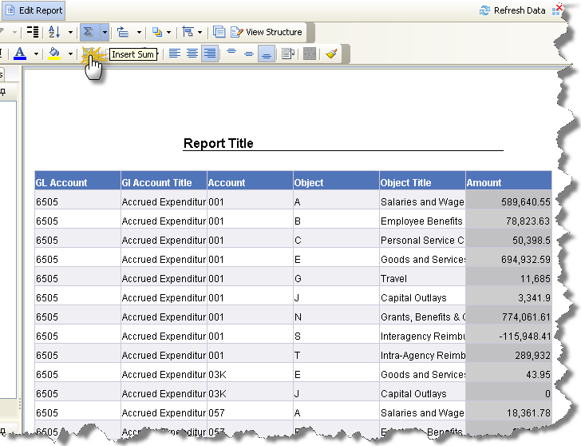

- Navigate to the end of the report.

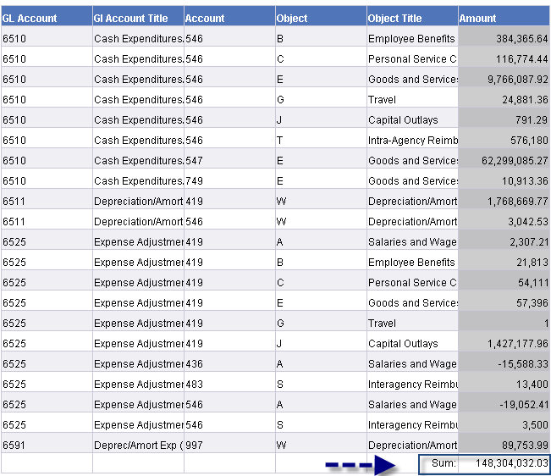
- In the upper left hand corner, click on the drop down box next the Save icon. When prompted, click on the ‘Save as’ option. Save your query in your Favorites folder as “Exercise 3 – Report Formatting”

- Return to your home screen.

End of Exercise

