|  |  |
| --- | --- |
|  | 21st Century  Latin American  Cinema Showcase |

**Noon to 1 p.m., Tuesday, September 28 on Zoom**

[**Pre-register for this meeting**](https://us02web.zoom.us/meeting/register/tZItduiupjkiHtXIcd7JEkE2Hd52vsLqrWRu)

In this webinar LLN member Nohemy Solórzano-Thompson will highlight a set of influential and critically-acclaimed 21st century feature-length fiction films from Latin America, primarily focusing on cinema from Argentina, Brazil, the Caribbean, Chile, Mexico, and Venezuela. The showcase will highlight films from the past 20 years that are readily available for renting and purchasing in the United States. We will also briefly discuss how Latin American cinema is financed, produced, and distributed – which is markedly different from how most films in the United States are made.

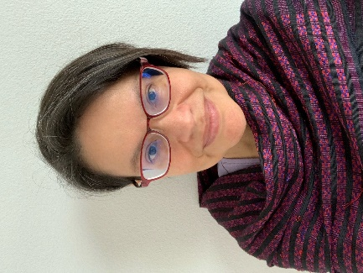Nohemy Solórzano-Thompson is a DEI Learning Design and Delivery Professional with the state Department of Enterprise Services. Prior to state service, she was a college faculty member and administrator for 17 years. Her teaching and published research focused on the portrayal of gender identities and sexuality in Latin American and Iberian film, theater, popular culture, and performance. Nohemy has a PhD in Latin American Literatures and Cultures and previously served as the chair of the National Association for Chicana and Chicano Studies (NACCS) and the Mujeres Activas en Letras y Cambio Social (MALCS) academic professional organizations. She is a first generation American of immigrant parents from Mexico and Nicaragua.

](https://www.cha.wa.gov/latino-leadership-network-2)

*The Latino Leadership Network (LLN) is a resource group for people working in Washington State government. We are Latinos and allies striving to build, connect, and inspire our peers and people seeking to join public service.*

[](https://www.youtube.com/channel/UCUV75VMCRBcCXP5vMtoPZxg)[](https://www.linkedin.com/in/latino-leadership-network-1b4870158/)[](https://www.facebook.com/WAworkers)