Standard Work Instruction
Process Name: Group C Assignment Pay Agency Requesting Authority
Operator: Agency/Institution Classification/Compensation Specialist
Operation Name: Formulating/Submitting Request to State Human Resources (SHR)
Task |  | Key Points | Visual References
1.  (120 min) | Appointing Authority requests additional pay | Works with agency assigned HR Manager/Consultant to determine if a recruitment and/or retention problem exists that could be resolved with additional dollars.
2.  (120 min) | Agency/Institution Class/Comp Specialist | - Opens and reviews Assignment Pay webpage for reference materials at: http://www.hr.wa.gov/CompClass/Compensation/Pages/AssignmentPay.aspx  - Briefs and consults with SHR Classification and Compensation Team on possibility of submitting a request | 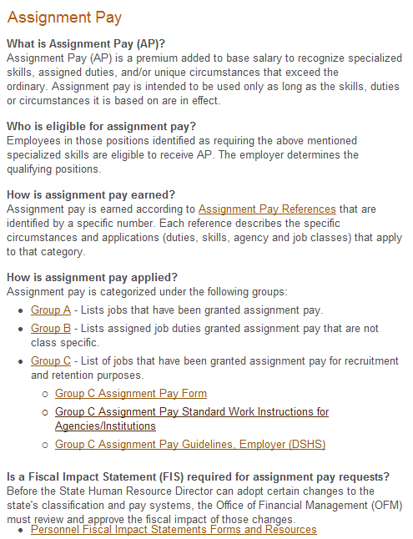
3.  (120 min) | Agency/Institution Class/Comp Specialist | Gathers/requests recruitment/retention data for last two years. Determines if class(s) are used in other agencies/institutions and impact (if any)  - Reviews assignment pay information on SHR’s website  - If not available internally, requests retention data from SHR via strategichr@ofm.wa.gov .  - Analyzes recruitment and retention data  Reference: Employer (DSHS) Group C Assignment Pay Guidelines
4.  (120 min) | Agency/Institution Class/Comp Specialist | Works with the Appointing Authority on developing a written description of the problem they are experiencing with the class/series, the adverse effects, and what actions have been taken to resolve the problem(s). Explains how a pay increase will help resolve problem(s). | 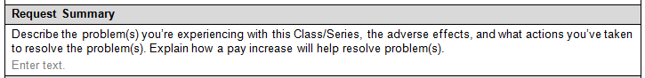
5.  (60 min) | Agency/Institution Class/Comp Specialist | Finalizes then forwards the request with their completed section (approved by the Director/Secretary) to SHR’s Classification and Compensation Team, and addresses any questions they may have. | 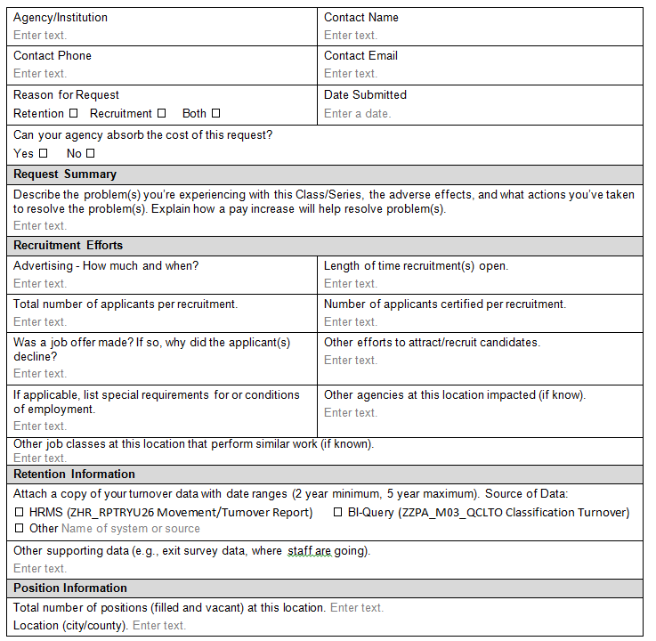
6.  (60 min) | Agency/Institution Class/Comp Specialist | Once SHRD sends the Fiscal Impact Statement (FIS), coordinates finalization with program and budget then submits to OFM Budget with copy to SHR. | 