5 Whys Root Cause Analysis

What is Root Cause Analysis and why should I use it?
Root cause analysis is a systematic process for identifying the root or underlying causes of problems. Root cause analysis helps you get past symptoms or surface reasons to the true source of the problem.

What is the 5 Whys technique for root cause analysis and how do I do it?
The 5 Whys technique involves asking “why?” multiple times until you reach the problem’s source. Follow these steps:

- Write down the problem.
- Ask: “Why is this problem occurring?”
- Generate a concise reason the problem exists. If there is more than one, write them all down.
- For each reason, ask “Why is that occurring?” and document the responses.
- Keep asking “Why?” until you reach the root or source cause.

Tips:
- You may have to ask “Why?” more or less than five times – it’s a guide, not a rule.
- Focus on one problem and one line of cause at a time.
- Go observe the work actually happening to confirm causes.
- When you reach a circular answer like “because that’s just the way it is” then you have likely reached root cause.

Example:
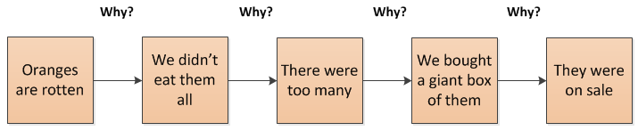
The “Therefore” Test:
To check that your cause logic is sound, work your way from the root cause to the problem, saying “therefore” or “so” each time.

Example:
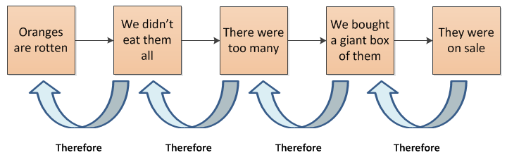

What if there is more than one line of cause?
Often there is more than one possible reason for the problem. As noted in step 3 of the technique, write down all of the possible causes. You can then organize them as shown below. This is often called an Issue Tree.

