

Submitting Vendor Forms with DocuSign™
The Vendor forms can be signed electronically with a digital signature via DocuSign™.
The Statewide Vendor/Payee Services provides the following forms that can be signed via DocuSign™:
- Vendor/payee Registration form (DocuSign™)
- Vendor/payee Change form (DocuSign™)
- Direct Deposit Authorization form (DocuSign™)
Follow the instructions below to sign your forms and your electronic signature will be accepted.
Please note that the example below is for the Vendor/payee registration form but it’s applicable to other forms.

Completing the form
- Open a form with the link provided above. You will be directed to the forms informational starting page. The page will look similar to this:
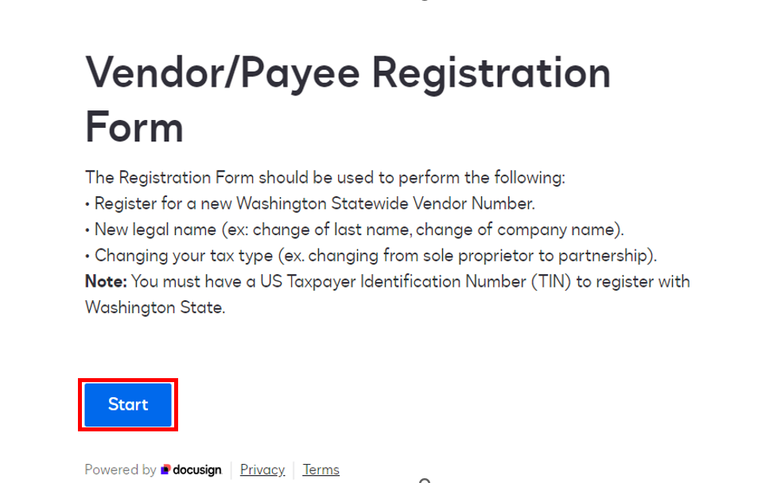
- Click START to begin signing.
- You will be directed to the Signer information page:
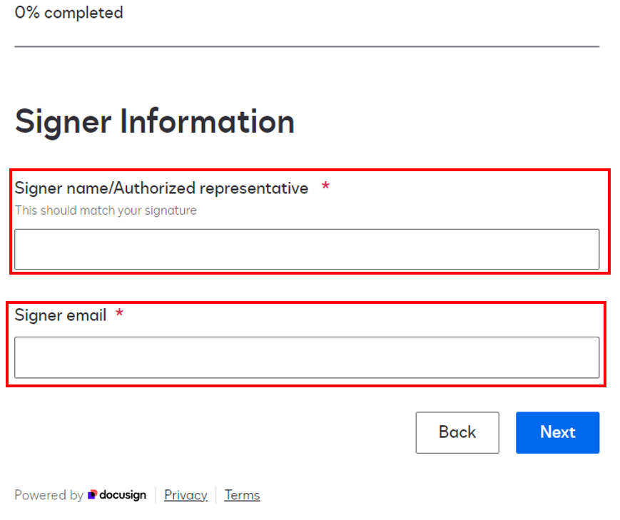
- The signer’s name MUST be an Individual person’s name and not the businesses name.
If the form is not signed by a person’s name, the form will be sent back for correction delaying the process.
- Signer email will be the email where a copy of the completed is emailed to you for your records.

- Your progress through the form will be shown in the top left corner as you fill it out and click "NEXT" to move through each section:


- The Summary screen will be displayed at the 75% point. Please review all information. Mistakes on forms will result in the forms being sent back for correction:


Signing the form via DocuSign™
- After reviewing the information summary page you will be directed to the disclosure page:
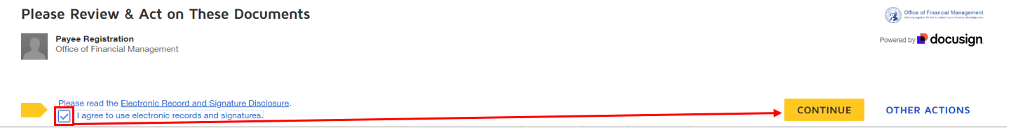
If you agree with the Electronic Record and Signature Disclosure, check the “I agree to use electronic records and signatures” checkbox and select the CONTINUE button.
- The form opens, select the START button. You can click NEXT through all the fields or make any last-minute changes as needed:
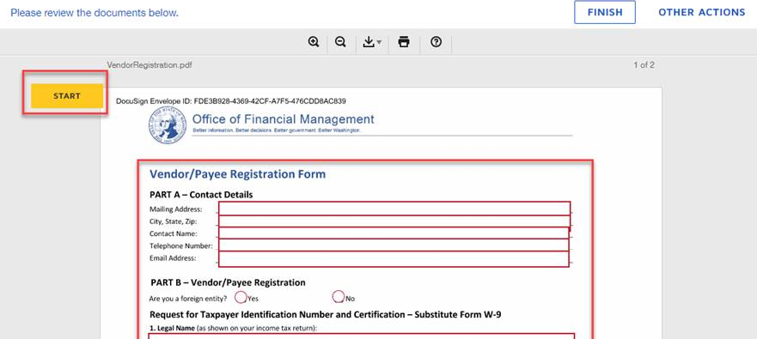

- Once you’re done reviewing the required fields, select the Sign button at the bottom of the page:
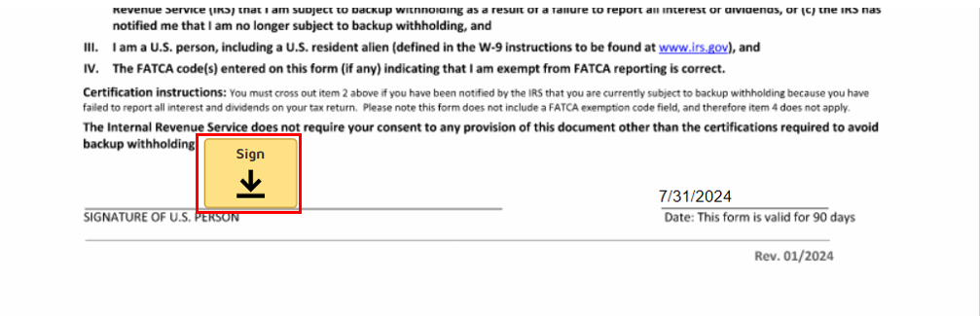

- The adopt a signature screen will open:
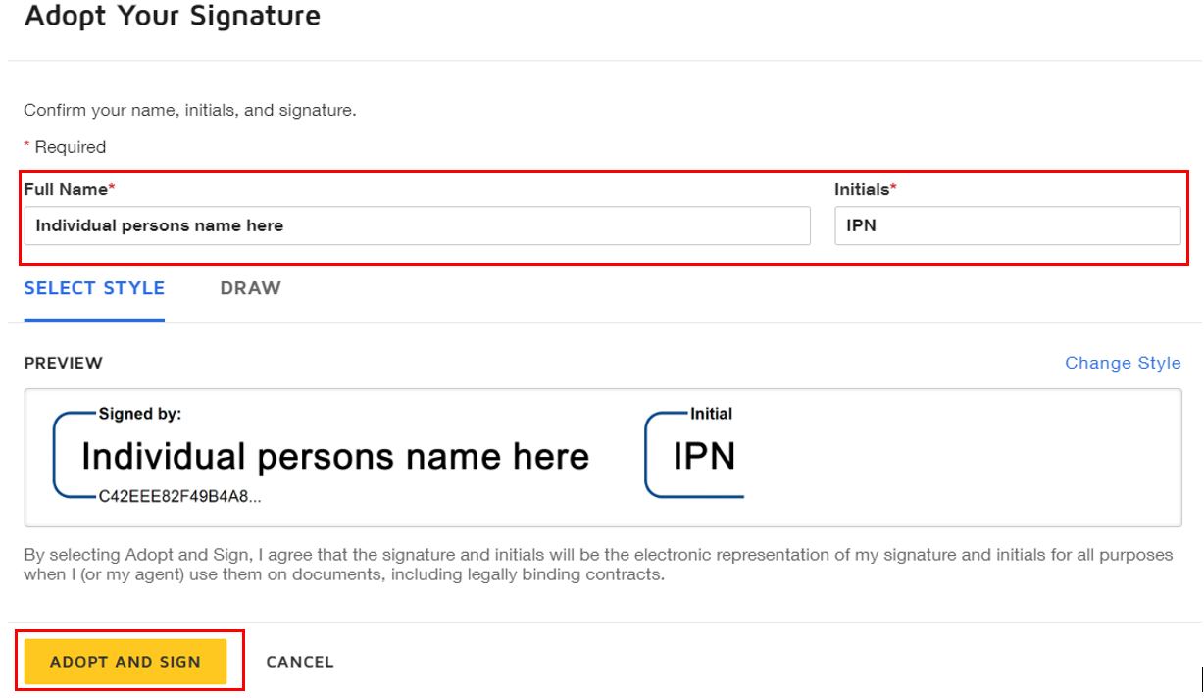
Accept the default signature by selecting ADOPT AND SIGN button
Make sure you sign with your name, not the business name. If the Preview box shows the business name, change it to the signer’s name.
- Select the ADOPT AND SIGN button when done.

- You will need to click FINISH on the document for the form to be completed and uploaded into our system for processing:

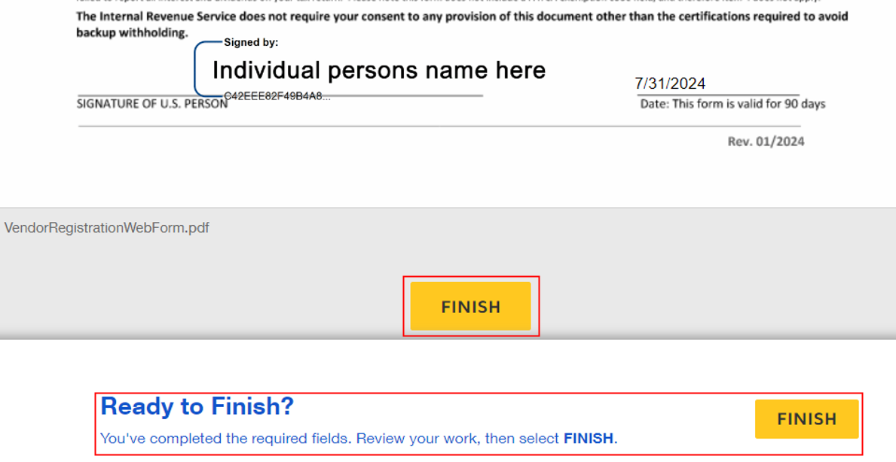

- You will be directed to the Thank you page:
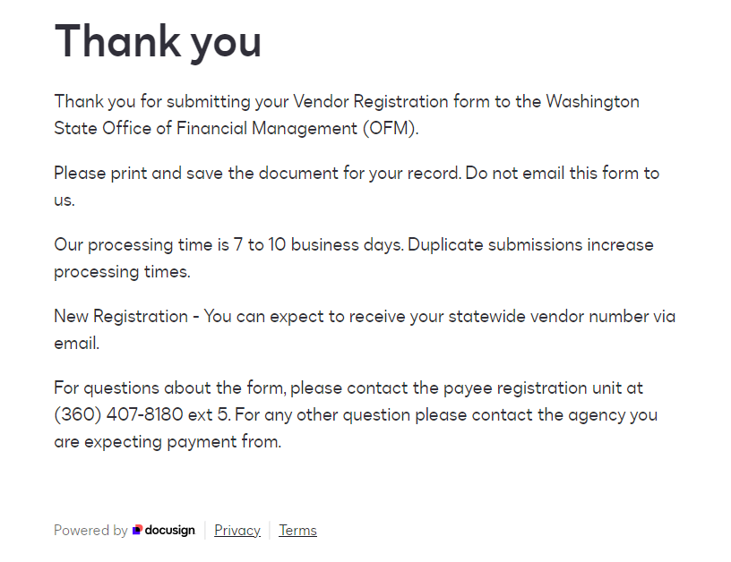

- Check your mailbox, you will receive a confirmation email with the signed form attached:
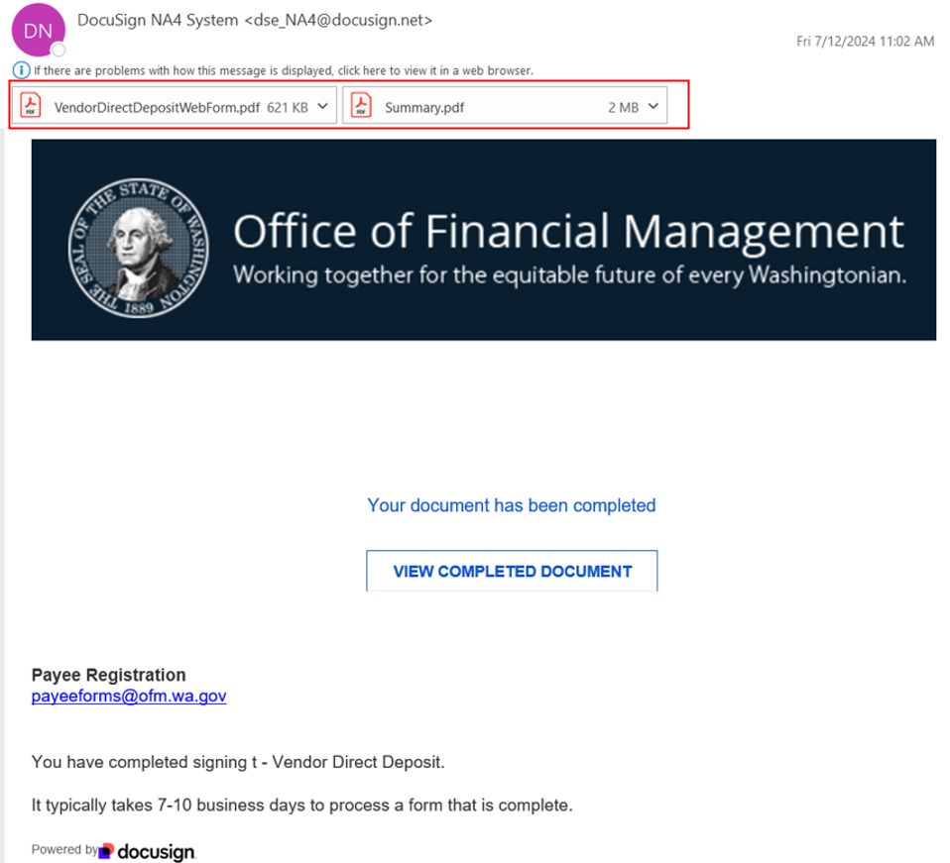
You can save the attached form for reference but do not email the form to us.

This concludes your signing process.
It typically takes 7-10 business days to process a registration, change, or direct deposit form that is complete.
For questions about the form, please contact the Payee Registration Unit at (360) 407-8180 ext. 5. For any other questions, please contact the agency you are expecting payment from.

