How to Find out of Balances GL 5181

Video instructions can be located here: https://youtu.be/1KC0C9JIDFk?si=zG4cyi1En1w2xxsp

There are three reports needed to compile the out of balances for 5181. They are the EOS MDR report (Miscellaneous Deduction Register Form A5-1), ZHR_RPTPY126 (HRMS report), and the AFRS Enterprise Report (General Ledger Analysis Flexible).

How to pull the AFRS Report from Enterprise Reporting (ER)
- Log into Enterprise Reporting: Reporting Portal 0 (wa.gov)
- Click on “Financial Reports” on the left side of the screen.
- Click on “General Ledgers”
- Right click on “General Ledger Analysis Flexible”.
- Click on Schedule
- Change the format to “Microsoft Excel Workbook Data-Only”
- Change the agency to the agency you are working on.
- Change the begin and end fiscal month to the month you are reconciling.
- Change the Account to 035.
- Change the General Ledger to 5181.
- Click on Schedule.
- When the report is done, you will right click on it and press “View”.
- Open the Excel file.
- Click the triangle in the upper left corner of the Excel spreadsheet.
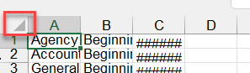
- Double click the line between column A&B to expand the columns.
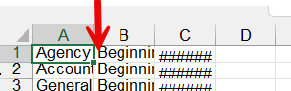
- While the sheet is still highlighted, double click the line between rows 1&2 to expand the rows.
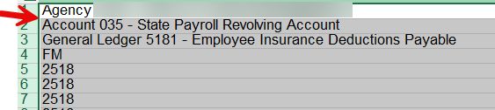
- Save document to your specified files for reconciliation.
- Create a second tab in the Excel file, name the tab MDR.

How to pull the MDR Report
- You will need to log into EOS to get the MDR Report. The username / password is the same for EOS as they are for AFRS. This is the link to the page RSD Business Services (wa.gov)
- Once the page loads, click on EOS.

- The report title is MDR A5-1. It is important that these are pulled monthly as they are only retained for 3 months on EOS. Tip- set a monthly reminder to pull them on the 25th.
- Export the file by pressing the first button on the left “Export”
- When the pop-up box appears, click on “Export”
- Open the text file and save it to your specified location for reconciliation files.
- Highlight the data by pressing <ctrl> A
- Copy text file data and paste it into the tab labeled MDR.
- Highlight column A and click on the Data tab > Text to Columns.
- Once the pop-up box appears, make sure “Fixed width” radio button is selected, click next.
- Scroll down until you can see the headers “SSN, PERNR, EMPLOYEE NAME, etc.”

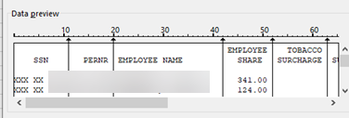

- Double click the lines to remove them and click to enter a line. You want a line in between each section header. Be sure to scroll all the way over till you have a “Total” column. Tip- look for negative numbers to ensure columns line up correctly.

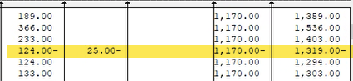

- Click Finish
- Highlight the spreadsheet and expand the columns so that you can read the data.
- Highlight all the data by clicking on upper left triangle.
- Sort the data by SSN (column A), make sure the My data has headers is unchecked.
- Delete the rows with headers (top of spreadsheet) and footers (bottom of spreadsheet) that are not employee data.
- Scroll to top of spreadsheet and insert a row for header data.
- Column A- SSN
- Column B- PERNR
- Column C- Employee Name
- Column D - EE
- Column E - Tobacco
- Column F -Spousal
- Column G – ER
- Column H - Total
- The spreadsheet should look like this:
- Format column D-H as a number with (0.00) selected and use 1000 separator.
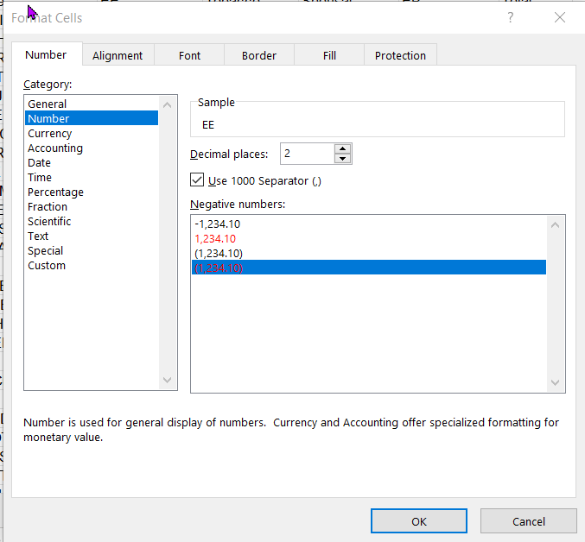

- We need to format all the personnel numbers as a number. Some are formatted as text if there are leading 0s.
- Insert Column between column B (PERNR) and column C (Employee Name)
- In Cell C2, create the following formula: =B2/1. Copy the formula down.
- Copy the data in column C then paste special values only to remove the formula
- Delete column B and rename column C to PERNR
- Review PERNR column for any missing personnel numbers. If missing add number. TIP- look for #VALUE! If you have multiple missing PERNR’s, you may want to run a S_AHR_61016362 - Flexible Employee Data report.
  - Select “Further Selections” and choose Personnel Area and Employment Status.
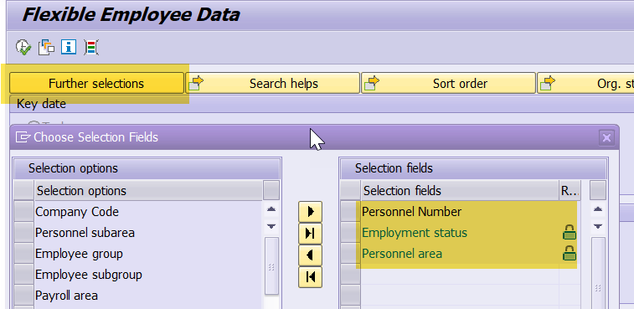
  - Under “Field selection” choose
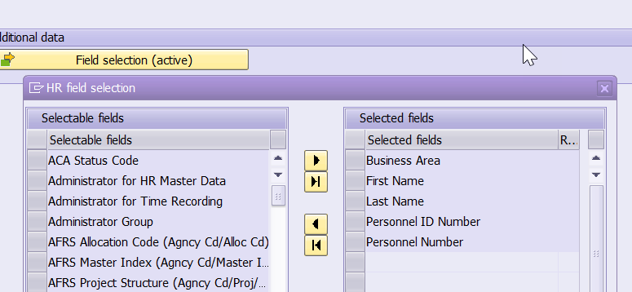
- After you enter missing PERNR’s Save

How to pull the 126 Report from HRMS
- In HRMS open the ZHR_RPTPY126 report (Payroll Posting Report).
- Click the variant box
- Remove your ID number and put “SWV 5181LAYOUT” in the Variant field.
- When the variant box pops up, select 035RECONLAYOUT (Top Option).
- Change the pay period, you are going to pull pay periods by pay date. This means for the month of March; you would pull the two pay periods that are paid in March which are 5 and 6.
- Change the Business Area to the agency you are working on.
- Filter for GL 5181* (this should already filtered from the variant)
- Execute the report
- Export as a spreadsheet
- Save in your specified location
- Insert a column in between C & D.
- Name the column Full Name
- Select cell D2. Use the Concatenate formula to combine the names in column B & C using this formula: =CONCATENATE(B2,", ",C2)
- Copy the formula down column D.
- Highlight Column D, Copy and then paste special values. This will lock your formula.
- Now, delete Columns B & C.
- Format Column E as a number with (0.00) selected and use 1000 separator.

- Save

How to Prepare the Reconciliation Spreadsheet
- Open the prior months reconciliation spreadsheet.
- If this is the first time you are using this reconciliation tool, you will need to transfer the employee details from your previous template to the new template.
- File, save as, the current month that you are going to reconcile. Example: Open March 2024, Save as April 2024.
- Change the biennium and FM in cell A4 on the reconciliation tab (if using the OFM template).
- Create new worksheet in your recon workbook and label “Combined 5181” (if you already have a tab label combined, delete the prior months information but keep the headers).
- On the Combined 5181 tab create the following Headers if needed: Personnel Number, Full Name, Wage Type, Wage Type Long Text, Amount, EE vs ER, Source, For-period payroll, In-period payroll, and Payment date.
- Open the 126 report you pulled for the month you are reconciling.
- Copy and paste columns A-E (not including headers) from the 126 report on to the same columns on the Combined 5181 tab of the recon spreadsheet. Copy columns F-H from the 126 report to columns H-J on the Combined 5181 tab.
- On the data just copied from the 126 report to the Combined 5181 tab, add 126 RPT in the source column (Column G).
- Now, from the MDR tab Report, Copy the data in columns B & C (not including headers) and paste at the bottom of the data in columns A & B on the Combined 5181 tab of the recon spreadsheet.
- Copy column D (EE premium) from the MDR report and paste into column E of the Combined 5181 tab of the recon spreadsheet.
- In Column F type EE, and in Column G type MDR. Copy “EE” and “MDR” down for all the data you just pasted in step 10.
- The date in column J is the last day of the month. For April it would be 4/30/2024. Copy the date down for all the data you just pasted in step 10.
- Filter the MDR report by Tobacco for any row that has data.
- Copy the data in columns B & C and paste at the bottom of the data in columns A & B on the Combined 5181 tab of the recon spreadsheet.
- Copy the amounts in Column E on the MDR report and paste into column E of the Combined 5181 tab of the recon spreadsheet.
- In Column F type TC, and in Column G type MDR. Do not include blank dollar amounts.
- Copy TC down for all the data you just pasted in step 15.
- The date in column J is the last day of the month. For April it would be 4/30/2024. Copy the date down for all the data you just pasted in step 15.
- Filter the MDR report by Spousal (make sure to undo filter for tobacco).
- Copy the data in columns B & C and paste at the bottom of the data in columns A & B on the Combined 5181 tab of the recon spreadsheet.
- Copy the amounts in Column F on the MDR report and paste into column E of the Combined 5181 tab of the recon spreadsheet.
- In Column F type SC, and in Column G type MDR. Do not include blank dollar amounts.
- Copy TC down for all the data you just pasted in step 21.
- The date in column J is the last day of the month. For April it would be 4/30/2024. Copy the data down for all the data you just pasted in step 21.
- Filter the MDR report by ER (make sure to undo Spousal filter). Do not include blank dollar amounts.
- Copy the data in columns B & C and paste at the bottom of the data in columns A & B on the Combined 5181 tab of the recon spreadsheet.
- Copy the amounts in Column G on the MDR report and paste into column E of the Combined 5181 tab of the recon spreadsheet.
- In Column F type ER, and in Column G type MDR.
- Copy ER down for all the data you just pasted in step 27.
- The date in column J is the last day of the month. For April it would be 4/30/2024. Copy the data down for all the data you just pasted in step 27.
- Save
- Now, sort the spreadsheet by Personnel Number (column A). Make sure the radio button: “Sort anything that looks like a number, as a number” is selected.
- Right click on the Combined 5181 tab, select move or copy, (move to end), check the box “create a copy” and click OK.
- Label this copy, Out of Balances 5181.
- Next, highlight the spreadsheet. From the data tab in excel click the subtotal. When the pop-up box appears, click at each change in Personnel Number, Use function Sum, Add subtotal to Amount. Click OK.
- Now, click on the number 2 in the upper left corner of the spreadsheet.
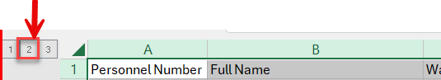
- Highlight all the rows and sort by column E, smallest to largest. Be sure to uncheck the box that says, “my data has headers”. Do not include the header row, or the grand total row.
- Delete any rows that sum to 0. Tip you will have negative numbers on top and positive numbers on the bottom. The 0 amounts are in the middle. You will do this by highlighting all the rows that have a 0 balance, right click and click delete.
- Once all the rows with a 0 balance are deleted, click a cell in the table. Go to the data tab and click the subtotal button. Click the remove all button on the bottom left corner of the pop up. This is your out of balance for the month. This total plus any manual activity (JVs, PVs, TSFPPYYPP) in GL 5181 for the month should equal the activity on your Enterprise report for the month.
- Delete the Grand Total at the bottom of the worksheet.
- Ensure that your 5181 tab in your reconciliation workbook has enough rows in order to complete step 42.
- Copy all of the data from the Out of Balances 5181 tab to the 5181 tab.
- Sort by personnel number
- Enter the beginning balance from the ER report on your 5181 tab and ensure that the ending balance from the reconciliation tab is coming forward and matches your Enterprise Report.
- Add any manual activity (JVs, PVs, TSFPYYPP) from your Enterprise Report to the bottom of your 5181 worksheet (add the current doc # and dollar amount).
- Add employee details for any TSFPYYPP JVs shown on the Enterprise Report using ZHR_RPTPY376 report. If you have more than one mid-period transfer, you will want to list each employee separately on the 5181 tab. Make sure the total amount of the TSFP JVs equals the amount as shown on your Enterprise Report.
- Sort by personnel number again.

